WD2 – Implementing & Testing an Interactive Website

BMC Consulting

cur16117920

Niall Curley

2017

Contents

**Testing Your Website** 5

**Introduction** 5

**Test: Home (index.html)** 6

**Links in Main Navigation (index.html)** 6

**Hover Feature in Main Navigation (index.html)** 7

**Links in Side Navigation (index.html)** 8

**Links in Footer (index.html)** 9

**Browser Loading Time (index.html)** 10

**Page Content and Design & Grammar (index.html)** 11

**Alternative Text (index.html)** 12

**Test: Classes (classes.html)** 14

**Links in Main Navigation (classes.html)** 14

**Hover Feature in Main Navigation (classes.html)** 15

**Links in Side Navigation (classes.html)** 16

**Links in Footer (classes.html)** 17

**Browser Loading Time (classes.html)** 18

**Page Content and Design & Grammar (classes.html)** 19

**Alternative Text (classes.html)** 20

**Test:Classes (events.html)** 21

**Links in Main Navigation (events.html)** 21

**Hover Feature in Main Navigation (events.html)** 22

**Links in Side Navigation (events.html)** 23

**Links in Footer (events.html)** 24

**Browser Loading Time (events.html)** 25

**Page Content and Design & Grammar (events.html)** 26

**Alternative Text (events.html)** 27

**Test:Register (register.html)** 28

**Links in Main Navigation** 28

**Hover Feature in Main Navigation (register.html)** 29

**Links in Side Navigation (register.html)** 30

**Links in Footer (register.html)** 31

**Browser Loading Time (register.html)** 32

**Page Content and Design & Grammar (register.html)** 33

**Alternative Text (register.html)** 34

**Test: Disability (disability.html)** 35

**Links in Main Navigation (disability.html)** 35

**Hover Feature in Main Navigation (disability.html)** 36

**Links in Side Navigation (disability.html)** 37

**Links in Footer (disability.html)** 38

**Browser Loading Time (disability.html)** 39

**Page Content and Design & Grammar (disability.html)** 40

**Alternative Text & Links(disability.html)** 41

**Test: Contact Us (contact_us.html)** 42

**Links in Main Navigation (contact_us.html)** 42

**Hover Feature in Main Navigation (contact_us.html)** 43

**Links in Side Navigation (contact_us.html)** 44

**Links in Footer (contact_us.html)** 45

**Browser Loading Time (contact_us.html)** 46

**Page Content and Design & Grammar (contact_us.html)** 47

**Alternative Text (contact_us.html)** 48

**Test: FAQ (faq.html)** 49

**Links in Main Navigation (faq.html)** 49

**Hover Feature in Main Navigation (faq.html)** 50

**Links in Side Navigation (faq.html)** 51

**Links in Footer (faq.html)** 52

**Browser Loading Time (faq.html)** 53

**Page Content and Design & Grammar (faq.html)** 54

**Alternative Text (faq.html)** 55

**Test: Child Protection (child_protection.html)** 56

**Links in Main Navigation (child_protection.html)** 56

**Hover Feature in Main Navigation (child_protection.html)** 57

**Links in Side Navigation (child_protection.html)** 58

**Links in Footer (child_protection.html)** 59

**Browser Loading Time (child_protection.html)** 60

**Page Content and Design & Grammar (child_protection.html)** 61

**Alternative Text (child_protection.html)** 62

**Test: Work/Volunteer (work_volunteer.html)** 63

**Links in Main Navigation (work_volunteer.html)** 63

**Hover Feature in Main Navigation (work_volunteer.html)** 64

**Links in Side Navigation (work_volunteer.html)** 65

**Links in Footer (work_volunteer.html)** 66

**Browser Loading Time (work_volunteer.html)** 67

**Page Content and Design & Grammar (work_volunteer.html)** 68

**Alternative Text (work_volunteer.html)** 69

**Test: Terms of Use (terms_of _use.html)** 70

**Links in Main Navigation (terms_of _use.html)** 70

**Hover Feature in Main Navigation (terms_of _use.html)** 71

**Links in Side Navigation (terms_of _use.html)** 72

**Links in Footer (terms_of_use.html)** 73

**Browser Loading Time (terms of use.html)** 74

**Page Content and Design & Grammar (terms of use.html)** 75

**Alternative Text (terms of use.html)** 76

**Test: Privacy (privacy.html)** 76

**Links in Main Navigation (privacy.html)** 76

**Hover Feature in Main Navigation (privacy.html)** 78

**Links in Side Navigation (privacy.html)** 79

**Links in Footer (privacy.html)** 80

**Browser Loading Time (privacy.html)** 81

**Page Content and Design & Grammar (privacy.html)** 82

**Alternative Text (privacy.html)** 83

**Form Validation (register.html)** 84

**Form Validation (Work/Volunteer)** 85

**Form Validation for (Contact Us Page)** 86

**Screenshots Forms (Valid)** 87

**Screen Shot of Form (Empty input)** 88

**Screen Shot of Form (Invalid & Extreme inputs) - Email field** 89

**Screen Shot of Form (Invalid & Extreme inputs) - Post Code field** 90

**Screen Shot of Form (Invalid & Extreme Input) input into Phone Number field** 91

**Screen Shot of changes made to Links in Main Navigation (disability.html)** 92

**Screen Shot of Changes Made to Footer (all pages)** 94

**Screen Shot of Changes made to Home (index.html) Alternative Text** 95

**Changes made to Register(register.html)** 97

**Screen Shot of Changes to Disability (Alternative Text)** 98

**Screen Shot of Changes made to Contact Us (contact_us)** 100

**Report on Website** 102

**Review of FAQ** 104

**Actual Questions** 105

**Improvements – FAQs** 106

**Maintenance of the Icons Website** 107

**Support & Maintenance** 108

**Daily Maintenance** 108

**Weekly Maintenance** 109

**Monthly Maintenance** 110

**Yearly Maintenance** 111

**Appendix** 112

**Questionnaire** 112

# **Testing Your Website**

## **Introduction**

We will now test our website to assess whether it functions per the design. We will be using ‘Black Box Testing’ method. This is a methodical process where the input and expected outputs will be checked to ascertain whether the website will work for the user per their specifications. This test will *not* focus on the coding of the html or CSS only the users experience of its actual functionality.

Website Test Website Name: [www.Iconsdrama.co.uk](http://www.Iconsdrama.co.uk)

Tester: Niall Curley

# **Test: Home (index.html)**

## **Links in Main Navigation (index.html)**

|  |  |  |  |  |  |  |
| --- | --- | --- | --- | --- | --- | --- |
| Test | Description | Data Test | Browser | Expect Result | Result | Action |
| 1 | Main Navigation | Click Home | Google Chrome/Internet Explorer | index.html opens | Works as expected | none |
| 2 | Main Navigation | Click Classes | Google Chrome/Internet Explorer | classes.html opens | Works as expected | none |
| 3 | Main Navigation | Click Events | Google Chrome/Internet Explorer | events.html opens | Works as expected | none |
| 4 | Main Navigation | Click Register | Google Chrome/Internet Explorer | register.html opens | Works as expected | none |
| 5 | Main Navigation | Click Disability | Google Chrome/Internet Explorer | disability.html opens | Not opening | Changed Code in html |
| 6 | Main Navigation | Click Contact Us | Google Chrome/Internet Explorer | contact_us.html opens | Works as expected | none |

|  |  |  |  |  |  |  |
| --- | --- | --- | --- | --- | --- | --- |
| Test | Description | Data Test | Browser | Expect Result | Result | Action |
| 7 | Main Navigation | Check hover feature Home | Google Chrome/Internet Explorer | Link changes colour when cursor moves over | Works as expected | none |
| 8 | Main Navigation | Check hover feature Classes | Google Chrome/Internet Explorer | Link changes colour when cursor moves over | Works as expected | none |
| 9 | Main Navigation | Check hover feature Events | Google Chrome/Internet Explorer | Link changes colour when cursor moves over | Works as expected | none |
| 10 | Main Navigation | Check hover feature Register | Google Chrome/Internet Explorer | Link changes colour when cursor moves over | Works as expected | none |
| 11 | Main Navigation | Check hover feature Disability | Google Chrome/Internet Explorer | Link changes colour when cursor moves over | Works as expected | none |
| 12 | Main Navigation | Check hover feature Contact Us | Google Chrome/Internet Explorer | Link changes colour when cursor moves over | Works as expected | none |

## **Hover Feature in Main Navigation (index.html)**

## **Links in Side Navigation (index.html)**

|  |  |  |  |  |  |  |
| --- | --- | --- | --- | --- | --- | --- |
| Test | Description | Data Test | Browser | Expected Result | Result | Action |
| 13 | Side Navigation | Click FAQ | Google Chrome/Internet Explorer | Opens faq.html | Works as expected | None |
| 14 | Side Navigation | Click Child Protection | Google Chrome/Internet Explorer | Opens child_protection.html | Works as expected | None |
| 15 | Side Navigation | Click Work/Volunteer | Google Chrome/Internet Explorer | Opens work_volunteer.html | Works as expected | None |
| 16 | Side Navigation | Click Facebook Image Link | Google Chrome/Internet Explorer | Opens in browser in new tab | Works as expected | None |
| 17 | Side Navigation | Hover Feature FAQ | Google Chrome/Internet Explorer | Changes Colour | Works as expected | None |
| 18 | Side Navigation | Hover Feature Child Protection | Google Chrome/Internet Explorer | Changes Colour | Works as expected | None |
| 19 | Side Navigation | Hover Feature Work/Volunteer | Google Chrome/Internet Explorer | Changes Colour | Works as expected | None |

## **Links in Footer (index.html)**

|  |  |  |  |  |  |
| --- | --- | --- | --- | --- | --- |
| Test | Data Test | Browser | Expected Result | Result | Action |
| 20 | Click Home Link | Google Chrome/Internet Explorer | Opens page | Works as expected | None |
| 21 | Click Child Protection | Google Chrome/Internet Explorer | Opens page | Works as expected | None |
| 22 | Click Classes | Google Chrome/Internet Explorer | Opens page | Works as expected | None |
| 23 | Click Disability | Google Chrome/Internet Explorer | Opens page | Not opening | Changed Code in html |
| 24 | Click Events | Google Chrome/Internet Explorer | Opens page | Works as expected | None |
| 25 | Click FAQ | Google Chrome/Internet Explorer | Opens page | Works as expected | None |
| 26 | Click Contact Us | Google Chrome/Internet Explorer | Opens page | Works as expected | None |
| 27 | Click Register | Google Chrome/Internet Explorer | Opens page | Works as expected | None |
| 28 | Click Work/Volunteer | Google Chrome/Internet Explorer | Opens page | Works as expected | None |
| 29 | Click Terms Of Use | Google Chrome/Internet Explorer | Opens page | Works as expected | None |
| 30 | Click Privacy | Google Chrome/Internet Explorer | Opens page | Works as expected | None |
| 31 | Click Back To Top | Google Chrome/Internet Explorer | Moves up to top of page | Works as expected | None |
| 32 | Home Link Hover Feature | Google Chrome/Internet Explorer | Changes Colour | Works as expected | None |
| 33 | Child Protection Hover Feature | Google Chrome/Internet Explorer | Changes Colour | Works as expected | None |
| 34 | Classes Hover Feature | Google Chrome/Internet Explorer | Changes Colour | Works as expected | None |
| 35 | Disability Hover Feature | Google Chrome/Internet Explorer | Changes Colour | Works as expected | None |
| 36 | Events Hover Feature | Google Chrome/Internet Explorer | Changes Colour | Works as expected | None |
| 37 | FAQ Hover Feature | Google Chrome/Internet Explorer | Changes Colour | Works as expected | None |
| 38 | Contact Us Hover Feature | Google Chrome/Internet Explorer | Changes Colour | Works as expected | None |
| 39 | Register Hover Feature | Google Chrome/Internet Explorer | Changes Colour | Works as expected | None |
| 40 | Work/Volunteer Hover Feature | Google Chrome/Internet Explorer | Changes Colour | Works as expected | None |
| 41 | Terms Of Use Hover Feature | Google Chrome/Internet Explorer | Changes Colour | Works as expected | None |
| 42 | Privacy Hover Feature | Google Chrome/Internet Explorer | Changes Colour | Works as expected | None |
| 43 | Back To Top Hover Feature | Google Chrome/Internet Explorer | Changes Colour | Works as expected | None |

## **Browser Loading Time (index.html)**

|  |  |  |  |  |  |
| --- | --- | --- | --- | --- | --- |
| Test | Data Test | Browser | Expected Result | Result | Action |
| 20 | Click Home | Google Chrome/Internet Explorer | Load Page in 3 seconds | Works as expected | None |
| 21 | Click Child Protection | Google Chrome/Internet Explorer | Load Page in 3 seconds | Works as expected | None |
| 22 | Click Classes | Google Chrome/Internet Explorer | Load Page in 3 seconds | Works as expected | None |
| 23 | Click Disability | Google Chrome/Internet Explorer | Load Page in 3 seconds | Not opening | Changed Code in html |
| 24 | Click Events | Google Chrome/Internet Explorer | Load Page in 3 seconds | Works as expected | None |
| 25 | Click FAQ | Google Chrome/Internet Explorer | Load Page in 3 seconds | Works as expected | None |
| 26 | Click Contact Us | Google Chrome/Internet Explorer | Load Page in 3 seconds | Works as expected | None |
| 27 | Click Register | Google Chrome/Internet Explorer | Load Page in 3 seconds | Works as expected | None |
| 28 | Click Work/Volunteer | Google Chrome/Internet Explorer | Load Page in 3 seconds | Works as expected | None |
| 29 | Click Terms Of Use | Google Chrome/Internet Explorer | Load Page in 3 seconds | Works as expected | None |
| 30 | Click Privacy | Google Chrome/Internet Explorer | Load Page in 3 seconds | Works as expected | None |

## **Page Content and Design & Grammar (index.html)**

|  |  |  |  |  |  |
| --- | --- | --- | --- | --- | --- |
| Test | Data Test | Browser | Expected Result | Result | Action |
| 31 | Header – Background – CSS linking to Html | Google Chrome/Internet Explorer | Black/Blue Gradient should fill background | Works as Expected | None |
|  | Header - Text & Grammar check. | Google Chrome/Internet Explorer | Text spelt correctly with proper grammar. | Works as Expected | None |
| 32 | Navigation Bar – Background – CSS linking to Html | Google Chrome/Internet Explorer | Orange/Red Gradient should fill background | Works as Expected | None |
|  | Navigation Bar – Text & Grammar Check | Google Chrome/Internet Explorer | Text spelt correctly with proper grammar. | Works as Expected | None |
| 33 | Side Bar – Background – CSS linking to Html | Google Chrome/Internet Explorer | Orange/Red Gradient should fill background | Works as Expected | None |
|  | Side Bar – Text & Grammar Check | Google Chrome/Internet Explorer | Text spelt correctly with proper grammar. | Works as Expected | None |
| 34 | Body – Background – CSS linking to Html | Google Chrome/Internet Explorer | Yellow/Red Gradient should fill background | Works as Expected | None |
|  | Body – Text & Grammar Check | Google Chrome/Internet Explorer | Text spelt correctly with proper grammar. | Works as Expected | None |
| 35 | Footer – Background – CSS linking to Html | Google Chrome/Internet Explorer | Orange/Red Gradient should fill background | Works as Expected | None |
| 36 | Footer - Text & Grammar check. | Google Chrome/Internet Explorer | Text should read ‘Disability’ | Text wrongly imputed as ‘Disability Friendly’ should be ‘Disability’. | Deleted text and inputted correct text |
| 36 | h1, h2, h3, p (styling element – CSS linking to Html – text align centre - Georgia, serif, 1% padding-left) | Google Chrome/Internet Explorer | h1, h2, h3, p - styling should be in Georgia, serif, and be 1% from left side. | Works as Expected | None |

## **Alternative Text (index.html)**

Test simulation – when image wont load due to slow download speed etc, then text will appear instead e.g "girls dancing in circle". This will be simulated by putting text into image location so as to see text appear describing the image instead of image itself.

|  |  |  |  |  |  |
| --- | --- | --- | --- | --- | --- |
| Test | Data Test | Browser | Expected Result | Result | Action |
| 37 | Header – Logo Image (left)  "images/index-iconslogo.jpg" | Google Chrome/Internet Explorer | Text should appear instead of image. | Works as Expected | None |
| 38 | Header – Icons – Image (right)  "images/index-icons-faces.gif" | Google Chrome/Internet Explorer | Text should appear instead of image. | Works as Expected | None |
| 39 | Side Navigation – Facebook image.  "images/facebook_logo.jpg" | Google Chrome/Internet Explorer | Text should appear instead of image. | Works as Expected | None |
| 40 | Main Content – image - "images/index_youngkids” – top left. | Google Chrome/Internet Explorer | Text should appear instead of image. | Works as Expected | None |
| 41 | Main Content – image - "images/index_youngkids1.jpg" – top. | Google Chrome/Internet Explorer | Text should appear instead of image. | Works as Expected | None |
| 42 | Main Content – image - "images/index_youngkids2.jpg" – top. | Google Chrome/Internet Explorer | Text should appear instead of image. | Works as Expected | None |
| 43 | Main Content – image - "images/index_youngkids3.jpg" – top. | Google Chrome/Internet Explorer | Text should appear instead of image. | Not Working – alt feature was not inputted. | Alt feature written in. |
| 44 | Main Content – image - "images/aladdin.jpg" – bottom. | Google Chrome/Internet Explorer | Text should appear instead of image. | Works as Expected | None |
| 45 | Main Content – image - "images/BeautynBeast.jpg" – bottom. | Google Chrome/Internet Explorer | Text should appear instead of image. | Works as Expected | None |
| 46 | Main Content – image - "images/peterpan.jpg" – bottom. | Google Chrome/Internet Explorer | Text should appear instead of image. | Works as Expected | None |
| 47 | Main Content – image - "images/shrek.jpg" – bottom. | Google Chrome/Internet Explorer | Text should appear instead of image. | Works as Expected | None |

# **Test: Classes (classes.html)**

## **Links in Main Navigation (classes.html)**

|  |  |  |  |  |  |  |
| --- | --- | --- | --- | --- | --- | --- |
| Test | Description | Data Test | Browser | Expect Result | Result | Action |
| 1 | Main Navigation | Click Home | Google Chrome/Internet Explorer | index.html opens | Works as expected | none |
| 2 | Main Navigation | Click Classes | Google Chrome/Internet Explorer | classes.html opens | Works as expected | None |
| 3 | Main Navigation | Click Events | Google Chrome/Internet Explorer | events.html opens | Works as expected | None |
| 4 | Main Navigation | Click Register | Google Chrome/Internet Explorer | register.html opens | Works as expected | None |
| 5 | Main Navigation | Click Disability | Google Chrome/Internet Explorer | disability.html opens | Not opening | Changed Code in html |
| 6 | Main Navigation | Click Contact Us | Google Chrome/Internet Explorer | contact_us.html opens | Works as expected | None |

|  |  |  |  |  |  |  |
| --- | --- | --- | --- | --- | --- | --- |
| Test | Description | Data Test | Browser | Expect Result | Result | Action |
| 7 | Main Navigation | Check hover feature Home | Google Chrome/Internet Explorer | Link changes colour when cursor moves over | Works as expected | None |
| 8 | Main Navigation | Check hover feature Classes | Google Chrome/Internet Explorer | Link changes colour when cursor moves over | Works as expected | None |
| 9 | Main Navigation | Check hover feature Events | Google Chrome/Internet Explorer | Link changes colour when cursor moves over | Works as expected | None |
| 10 | Main Navigation | Check hover feature Register | Google Chrome/Internet Explorer | Link changes colour when cursor moves over | Works as expected | None |
| 11 | Main Navigation | Check hover feature Disability | Google Chrome/Internet Explorer | Link changes colour when cursor moves over | Works as expected | None |
| 12 | Main Navigation | Check hover feature Contact Us | Google Chrome/Internet Explorer | Link changes colour when cursor moves over | Works as expected | None |

## **Hover Feature in Main Navigation (classes.html)**

## **Links in Side Navigation (classes.html)**

|  |  |  |  |  |  |  |
| --- | --- | --- | --- | --- | --- | --- |
| Test | Description | Data Test | Browser | Expected Result | Result | Action |
| 13 | Side Navigation | Click FAQ | Google Chrome/Internet Explorer | Opens faq.html | Works as expected | None |
| 14 | Side Navigation | Click Child Protection | Google Chrome/Internet Explorer | Opens child_protection.html | Works as expected | None |
| 15 | Side Navigation | Click Work/Volunteer | Google Chrome/Internet Explorer | Opens work_volunteer.html | Works as expected | None |
| 16 | Side Navigation | Click Facebook Image Link | Google Chrome/Internet Explorer | Opens in browser in new tab | Works as expected | None |
| 17 | Side Navigation | Hover Feature FAQ | Google Chrome/Internet Explorer | Changes Colour | Works as expected | None |
| 18 | Side Navigation | Hover Feature Child Protection | Google Chrome/Internet Explorer | Changes Colour | Works as expected | None |
| 19 | Side Navigation | Hover Feature Work/Volunteer | Google Chrome/Internet Explorer | Changes Colour | Works as expected | None |

## **Links in Footer (classes.html)**

|  |  |  |  |  |  |
| --- | --- | --- | --- | --- | --- |
| Test | Data Test | Browser | Expected Result | Result | Action |
| 20 | Click Home Link | Google Chrome/Internet Explorer | Opens page | Works as expected | None |
| 21 | Click Child Protection | Google Chrome/Internet Explorer | Opens page | Works as expected | None |
| 22 | Click Classes | Google Chrome/Internet Explorer | Opens page | Works as expected | None |
| 23 | Click Disability | Google Chrome/Internet Explorer | Opens page | Not opening | Changed Code in html |
| 24 | Click Events | Google Chrome/Internet Explorer | Opens page | Works as expected | None |
| 25 | Click FAQ | Google Chrome/Internet Explorer | Opens page | Works as expected | None |
| 26 | Click Contact Us | Google Chrome/Internet Explorer | Opens page | Works as expected | None |
| 27 | Click Register | Google Chrome/Internet Explorer | Opens page | Works as expected | None |
| 28 | Click Work/Volunteer | Google Chrome/Internet Explorer | Opens page | Works as expected | None |
| 29 | Click Terms Of Use | Google Chrome/Internet Explorer | Opens page | Works as expected | None |
| 30 | Click Privacy | Google Chrome/Internet Explorer | Opens page | Works as expected | None |
| 31 | Click Back To Top | Google Chrome/Internet Explorer | Moves up to top of page | Works as expected | None |
| 32 | Home Link Hover Feature | Google Chrome/Internet Explorer | Changes Colour | Works as expected | None |
| 33 | Child Protection Hover Feature | Google Chrome/Internet Explorer | Changes Colour | Works as expected | None |
| 34 | Classes Hover Feature | Google Chrome/Internet Explorer | Changes Colour | Works as expected | None |
| 35 | Disability Hover Feature | Google Chrome/Internet Explorer | Changes Colour | Works as expected | None |
| 36 | Events Hover Feature | Google Chrome/Internet Explorer | Changes Colour | Works as expected | None |
| 37 | FAQ Hover Feature | Google Chrome/Internet Explorer | Changes Colour | Works as expected | None |
| 38 | Contact Us Hover Feature | Google Chrome/Internet Explorer | Changes Colour | Works as expected | None |
| 39 | Register Hover Feature | Google Chrome/Internet Explorer | Changes Colour | Works as expected | None |
| 40 | Work/Volunteer Hover Feature | Google Chrome/Internet Explorer | Changes Colour | Works as expected | None |
| 41 | Terms Of Use Hover Feature | Google Chrome/Internet Explorer | Changes Colour | Works as expected | None |
| 42 | Privacy Hover Feature | Google Chrome/Internet Explorer | Changes Colour | Works as expected | None |
| 43 | Back To Top Hover Feature | Google Chrome/Internet Explorer | Changes Colour | Works as expected | None |

## **Browser Loading Time (classes.html)**

|  |  |  |  |  |  |
| --- | --- | --- | --- | --- | --- |
| Test | Data Test | Browser | Expected Result | Result | Action |
| 20 | Click Home | Google Chrome/Internet Explorer | Load Page in 3 seconds | Works as expected | None |
| 21 | Click Child Protection | Google Chrome/Internet Explorer | Load Page in 3 seconds | Works as expected | None |
| 22 | Click Classes | Google Chrome/Internet Explorer | Load Page in 3 seconds | Works as expected | None |
| 23 | Click Disability | Google Chrome/Internet Explorer | Load Page in 3 seconds | Not opening | Changed Code in html |
| 24 | Click Events | Google Chrome/Internet Explorer | Load Page in 3 seconds | Works as expected | None |
| 25 | Click FAQ | Google Chrome/Internet Explorer | Load Page in 3 seconds | Works as expected | None |
| 26 | Click Contact Us | Google Chrome/Internet Explorer | Load Page in 3 seconds | Works as expected | None |
| 27 | Click Register | Google Chrome/Internet Explorer | Load Page in 3 seconds | Works as expected | None |
| 28 | Click Work/Volunteer | Google Chrome/Internet Explorer | Load Page in 3 seconds | Works as expected | None |
| 29 | Click Terms Of Use | Google Chrome/Internet Explorer | Load Page in 3 seconds | Works as expected | None |
| 30 | Click Privacy | Google Chrome/Internet Explorer | Load Page in 3 seconds | Works as expected | None |

## **Page Content and Design & Grammar (classes.html)**

|  |  |  |  |  |  |
| --- | --- | --- | --- | --- | --- |
| Test | Data Test | Browser | Expected Result | Result | Action |
| 31 | Header – Background – CSS linking to Html | Google Chrome/Internet Explorer | Black/Blue Gradient should fill background | Works as Expected | None |
|  | Header - Text & Grammar check. | Google Chrome/Internet Explorer | Text spelt correctly with proper grammar. | Works as Expected | None |
| 32 | Navigation Bar – Background – CSS linking to Html | Google Chrome/Internet Explorer | Orange/Red Gradient should fill background | Works as Expected | None |
|  | Navigation Bar – Text & Grammar Check | Google Chrome/Internet Explorer | Text spelt correctly with proper grammar. | Works as Expected | None |
| 33 | Side Bar – Background – CSS linking to Html | Google Chrome/Internet Explorer | Orange/Red Gradient should fill background | Works as Expected | None |
|  | Side Bar – Text & Grammar Check | Google Chrome/Internet Explorer | Text spelt correctly with proper grammar. | Works as Expected | None |
| 34 | Body – Background – CSS linking to Html | Google Chrome/Internet Explorer | Yellow/Red Gradient should fill background | Works as Expected | None |
|  | Body – Text & Grammar Check | Google Chrome/Internet Explorer | Text spelt correctly with proper grammar. | Works as Expected | None |
| 35 | Footer – Background – CSS linking to Html | Google Chrome/Internet Explorer | Orange/Red Gradient should fill background | Works as Expected | None |
| 36 | Footer - Text & Grammar check. | Google Chrome/Internet Explorer | Text should read ‘Disability’ | Text wrongly imputed as ‘Disability Friendly’ should be ‘Disability’. | Deleted text and inputted correct text |
| 36 | h1, h2, h3, p (styling element – CSS linking to Html – text align centre - Georgia, serif, 1% padding-left) | Google Chrome/Internet Explorer | h1, h2, h3, p - styling should be in Georgia, serif, and be 1% from left side. | Works as Expected | None |

## **Alternative Text (classes.html)**

## 

Test simulation – when image wont load due to slow download speed etc, then text will appear instead e.g "girls dancing in circle". This will be simulated by putting text into image location so as to see text appear describing the image instead of image itself.

|  |  |  |  |  |  |
| --- | --- | --- | --- | --- | --- |
| Test | Data Test | Browser | Expected Result | Result | Action |
| 37 | Header – Logo Image (left)  "images/index-iconslogo.jpg" | Google Chrome/Internet Explorer | Text should appear instead of image. | Works as Expected | None |
| 38 | Header – Icons – Image (right)  "images/index-icons-faces.gif" | Google Chrome/Internet Explorer | Text should appear instead of image. | Works as Expected | None |
| 39 | Side Navigation – Facebook image.  "images/facebook_logo.jpg" | Google Chrome/Internet Explorer | Text should appear instead of image. | Works as Expected | None |
| 40 | Main Content – image - "images/classes_different_ages.jpg" – top right. | Google Chrome/Internet Explorer | Text should appear instead of image. | Works as Expected | None |

# **Test:Classes (events.html)**

## **Links in Main Navigation (events.html)**

|  |  |  |  |  |  |  |
| --- | --- | --- | --- | --- | --- | --- |
| Test | Description | Data Test | Browser | Expect Result | Result | Action |
| 1 | Main Navigation | Click Home | Google Chrome/Internet Explorer | index.html opens | Works as expected | none |
| 2 | Main Navigation | Click Classes | Google Chrome/Internet Explorer | classes.html opens | Works as expected | none |
| 3 | Main Navigation | Click Events | Google Chrome/Internet Explorer | events.html opens | Works as expected | none |
| 4 | Main Navigation | Click Register | Google Chrome/Internet Explorer | register.html opens | Works as expected | none |
| 5 | Main Navigation | Click Disability | Google Chrome/Internet Explorer | disability.html opens | Not opening | Changed Code in html |
| 6 | Main Navigation | Click Contact Us | Google Chrome/Internet Explorer | contact_us.html opens | Works as expected | none |

|  |  |  |  |  |  |  |
| --- | --- | --- | --- | --- | --- | --- |
| Test | Description | Data Test | Browser | Expect Result | Result | Action |
| 7 | Main Navigation | Check hover feature Home | Google Chrome/Internet Explorer | Link changes colour when cursor moves over | Works as expected | none |
| 8 | Main Navigation | Check hover feature Classes | Google Chrome/Internet Explorer | Link changes colour when cursor moves over | Works as expected | none |
| 9 | Main Navigation | Check hover feature Events | Google Chrome/Internet Explorer | Link changes colour when cursor moves over | Works as expected | none |
| 10 | Main Navigation | Check hover feature Register | Google Chrome/Internet Explorer | Link changes colour when cursor moves over | Works as expected | none |
| 11 | Main Navigation | Check hover feature Disability | Google Chrome/Internet Explorer | Link changes colour when cursor moves over | Works as expected | none |
| 12 | Main Navigation | Check hover feature Contact Us | Google Chrome/Internet Explorer | Link changes colour when cursor moves over | Works as expected | none |

## **Hover Feature in Main Navigation (events.html)**

## **Links in Side Navigation (events.html)**

|  |  |  |  |  |  |  |
| --- | --- | --- | --- | --- | --- | --- |
| Test | Description | Data Test | Browser | Expected Result | Result | Action |
| 13 | Side Navigation | Click FAQ | Google Chrome/Internet Explorer | Opens faq.html | Works as expected | None |
| 14 | Side Navigation | Click Child Protection | Google Chrome/Internet Explorer | Opens child_protection.html | Works as expected | None |
| 15 | Side Navigation | Click Work/Volunteer | Google Chrome/Internet Explorer | Opens work_volunteer.html | Works as expected | None |
| 16 | Side Navigation | Click Facebook Image Link | Google Chrome/Internet Explorer | Opens in browser in new tab | Works as expected | None |
| 17 | Side Navigation | Hover Feature FAQ | Google Chrome/Internet Explorer | Changes Colour | Works as expected | None |
| 18 | Side Navigation | Hover Feature Child Protection | Google Chrome/Internet Explorer | Changes Colour | Works as expected | None |
| 19 | Side Navigation | Hover Feature Work/Volunteer | Google Chrome/Internet Explorer | Changes Colour | Works as expected | None |

## **Links in Footer (events.html)**

|  |  |  |  |  |  |
| --- | --- | --- | --- | --- | --- |
| Test | Data Test | Browser | Expected Result | Result | Action |
| 20 | Click Home Link | Google Chrome/Internet Explorer | Opens page | Works as expected | None |
| 21 | Click Child Protection | Google Chrome/Internet Explorer | Opens page | Works as expected | None |
| 22 | Click Classes | Google Chrome/Internet Explorer | Opens page | Works as expected | None |
| 23 | Click Disability | Google Chrome/Internet Explorer | Opens page | Not opening | Changed Code in html |
| 24 | Click Events | Google Chrome/Internet Explorer | Opens page | Works as expected | None |
| 25 | Click FAQ | Google Chrome/Internet Explorer | Opens page | Works as expected | None |
| 26 | Click Contact Us | Google Chrome/Internet Explorer | Opens page | Works as expected | None |
| 27 | Click Register | Google Chrome/Internet Explorer | Opens page | Works as expected | None |
| 28 | Click Work/Volunteer | Google Chrome/Internet Explorer | Opens page | Works as expected | None |
| 29 | Click Terms Of Use | Google Chrome/Internet Explorer | Opens page | Works as expected | None |
| 30 | Click Privacy | Google Chrome/Internet Explorer | Opens page | Works as expected | None |
| 31 | Click Back To Top | Google Chrome/Internet Explorer | Moves up to top of page | Works as expected | None |
| 32 | Home Link Hover Feature | Google Chrome/Internet Explorer | Changes Colour | Works as expected | None |
| 33 | Child Protection Hover Feature | Google Chrome/Internet Explorer | Changes Colour | Works as expected | None |
| 34 | Classes Hover Feature | Google Chrome/Internet Explorer | Changes Colour | Works as expected | None |
| 35 | Disability Hover Feature | Google Chrome/Internet Explorer | Changes Colour | Works as expected | None |
| 36 | Events Hover Feature | Google Chrome/Internet Explorer | Changes Colour | Works as expected | None |
| 37 | FAQ Hover Feature | Google Chrome/Internet Explorer | Changes Colour | Works as expected | None |
| 38 | Contact Us Hover Feature | Google Chrome/Internet Explorer | Changes Colour | Works as expected | None |
| 39 | Register Hover Feature | Google Chrome/Internet Explorer | Changes Colour | Works as expected | None |
| 40 | Work/Volunteer Hover Feature | Google Chrome/Internet Explorer | Changes Colour | Works as expected | None |
| 41 | Terms Of Use Hover Feature | Google Chrome/Internet Explorer | Changes Colour | Works as expected | None |
| 42 | Privacy Hover Feature | Google Chrome/Internet Explorer | Changes Colour | Works as expected | None |
| 43 | Back To Top Hover Feature | Google Chrome/Internet Explorer | Changes Colour | Works as expected | None |

## **Browser Loading Time (events.html)**

|  |  |  |  |  |  |
| --- | --- | --- | --- | --- | --- |
| Test | Data Test | Browser | Expected Result | Result | Action |
| 20 | Click Home | Google Chrome/Internet Explorer | Load Page in 3 seconds | Works as expected | None |
| 21 | Click Child Protection | Google Chrome/Internet Explorer | Load Page in 3 seconds | Works as expected | None |
| 22 | Click Classes | Google Chrome/Internet Explorer | Load Page in 3 seconds | Works as expected | None |
| 23 | Click Disability | Google Chrome/Internet Explorer | Load Page in 3 seconds | Not opening | Changed Code in html |
| 24 | Click Events | Google Chrome/Internet Explorer | Load Page in 3 seconds | Works as expected | None |
| 25 | Click FAQ | Google Chrome/Internet Explorer | Load Page in 3 seconds | Works as expected | None |
| 26 | Click Contact Us | Google Chrome/Internet Explorer | Load Page in 3 seconds | Works as expected | None |
| 27 | Click Register | Google Chrome/Internet Explorer | Load Page in 3 seconds | Works as expected | None |
| 28 | Click Work/Volunteer | Google Chrome/Internet Explorer | Load Page in 3 seconds | Works as expected | None |
| 29 | Click Terms Of Use | Google Chrome/Internet Explorer | Load Page in 3 seconds | Works as expected | None |
| 30 | Click Privacy | Google Chrome/Internet Explorer | Load Page in 3 seconds | Works as expected | None |

## **Page Content and Design & Grammar (events.html)**

|  |  |  |  |  |  |
| --- | --- | --- | --- | --- | --- |
| Test | Data Test | Browser | Expected Result | Result | Action |
| 31 | Header – Background – CSS linking to Html | Google Chrome/Internet Explorer | Black/Blue Gradient should fill background | Works as Expected | None |
|  | Header - Text & Grammar check. | Google Chrome/Internet Explorer | Text spelt correctly with proper grammar. | Works as Expected | None |
| 32 | Navigation Bar – Background – CSS linking to Html | Google Chrome/Internet Explorer | Orange/Red Gradient should fill background | Works as Expected | None |
|  | Navigation Bar – Text & Grammar Check | Google Chrome/Internet Explorer | Text spelt correctly with proper grammar. | Works as Expected | None |
| 33 | Side Bar – Background – CSS linking to Html | Google Chrome/Internet Explorer | Orange/Red Gradient should fill background | Works as Expected | None |
|  | Side Bar – Text & Grammar Check | Google Chrome/Internet Explorer | Text spelt correctly with proper grammar. | Works as Expected | None |
| 34 | Body – Background – CSS linking to Html | Google Chrome/Internet Explorer | Yellow/Red Gradient should fill background | Works as Expected | None |
|  | Body – Text & Grammar Check | Google Chrome/Internet Explorer | Text spelt correctly with proper grammar. | Works as Expected | None |
| 35 | Footer – Background – CSS linking to Html | Google Chrome/Internet Explorer | Orange/Red Gradient should fill background | Works as Expected | None |
| 36 | Footer - Text & Grammar check. | Google Chrome/Internet Explorer | Text should read ‘Disability’ | Text wrongly imputed as ‘Disability Friendly’ should be ‘Disability’. | Deleted text and inputted correct text |
| 36 | h1, h2, h3, p (styling element – CSS linking to Html – text align centre - Georgia, serif, 1% padding-left) | Google Chrome/Internet Explorer | h1, h2, h3, p - styling should be in Georgia, serif, and be 1% from left side. | Works as Expected | None |

## **Alternative Text (events.html)**

## 

Test simulation – when image wont load due to slow download speed etc, then text will appear instead e.g "girls dancing in circle". This will be simulated by putting text into image location so as to see text appear describing the image instead of image itself.

|  |  |  |  |  |  |
| --- | --- | --- | --- | --- | --- |
| Test | Data Test | Browser | Expected Result | Result | Action |
| 37 | Header – Logo Image (left)  "images/index-iconslogo.jpg" | Google Chrome/Internet Explorer | Text should appear instead of image. | Works as Expected | None |
| 38 | Header – Icons – Image (right)  "images/index-icons-faces.gif" | Google Chrome/Internet Explorer | Text should appear instead of image. | Works as Expected | None |
| 39 | Side Navigation – Facebook image.  "images/facebook_logo.jpg" | Google Chrome/Internet Explorer | Text should appear instead of image. | Works as Expected | None |
| 40 | Main Content – image - "images/events-nativity.jpg" – top right. | Google Chrome/Internet Explorer | Text should appear instead of image. | Works as Expected | None |
|  | Main Content – image - "images/2015-cinderella.jpg" – middle of page. | Google Chrome/Internet Explorer | Text should appear instead of image. | Works as Expected | None |
|  | Main Content – image - "images/wizard%20of%20oz.jpg" – bottom of page. | Google Chrome/Internet Explorer | Text should appear instead of image. | Works as Expected | None |

# **Test:Register (register.html)**

## **Links in Main Navigation**

|  |  |  |  |  |  |  |
| --- | --- | --- | --- | --- | --- | --- |
| Test | Description | Data Test | Browser | Expect Result | Result | Action |
| 1 | Main Navigation | Click Home | Google Chrome/Internet Explorer | index.html opens | Works as expected | none |
| 2 | Main Navigation | Click Classes | Google Chrome/Internet Explorer | classes.html opens | Works as expected | none |
| 3 | Main Navigation | Click Events | Google Chrome/Internet Explorer | events.html opens | Works as expected | none |
| 4 | Main Navigation | Click Register | Google Chrome/Internet Explorer | register.html opens | Works as expected | none |
| 5 | Main Navigation | Click Disability | Google Chrome/Internet Explorer | disability.html opens | Not opening | Changed Code in html |
| 6 | Main Navigation | Click Contact Us | Google Chrome/Internet Explorer | contact_us.html opens | Works as expected | none |

|  |  |  |  |  |  |  |
| --- | --- | --- | --- | --- | --- | --- |
| Test | Description | Data Test | Browser | Expect Result | Result | Action |
| 7 | Main Navigation | Check hover feature Home | Google Chrome/Internet Explorer | Link changes colour when cursor moves over | Works as expected | none |
| 8 | Main Navigation | Check hover feature Classes | Google Chrome/Internet Explorer | Link changes colour when cursor moves over | Works as expected | none |
| 9 | Main Navigation | Check hover feature Events | Google Chrome/Internet Explorer | Link changes colour when cursor moves over | Works as expected | none |
| 10 | Main Navigation | Check hover feature Register | Google Chrome/Internet Explorer | Link changes colour when cursor moves over | Works as expected | none |
| 11 | Main Navigation | Check hover feature Disability | Google Chrome/Internet Explorer | Link changes colour when cursor moves over | Works as expected | none |
| 12 | Main Navigation | Check hover feature Contact Us | Google Chrome/Internet Explorer | Link changes colour when cursor moves over | Works as expected | none |

## **Hover Feature in Main Navigation (register.html)**

## **Links in Side Navigation (register.html)**

|  |  |  |  |  |  |  |
| --- | --- | --- | --- | --- | --- | --- |
| Test | Description | Data Test | Browser | Expected Result | Result | Action |
| 13 | Side Navigation | Click FAQ | Google Chrome/Internet Explorer | Opens faq.html | Works as expected | None |
| 14 | Side Navigation | Click Child Protection | Google Chrome/Internet Explorer | Opens child_protection.html | Works as expected | None |
| 15 | Side Navigation | Click Work/Volunteer | Google Chrome/Internet Explorer | Opens work_volunteer.html | Works as expected | None |
| 16 | Side Navigation | Click Facebook Image Link | Google Chrome/Internet Explorer | Opens in browser in new tab | Works as expected | None |
| 17 | Side Navigation | Hover Feature FAQ | Google Chrome/Internet Explorer | Changes Colour | Works as expected | None |
| 18 | Side Navigation | Hover Feature Child Protection | Google Chrome/Internet Explorer | Changes Colour | Works as expected | None |
| 19 | Side Navigation | Hover Feature Work/Volunteer | Google Chrome/Internet Explorer | Changes Colour | Works as expected | None |

## **Links in Footer (register.html)**

|  |  |  |  |  |  |
| --- | --- | --- | --- | --- | --- |
| Test | Data Test | Browser | Expected Result | Result | Action |
| 20 | Click Home Link | Google Chrome/Internet Explorer | Opens page | Works as expected | None |
| 21 | Click Child Protection | Google Chrome/Internet Explorer | Opens page | Works as expected | None |
| 22 | Click Classes | Google Chrome/Internet Explorer | Opens page | Works as expected | None |
| 23 | Click Disability | Google Chrome/Internet Explorer | Opens page | Not opening | Changed Code in html |
| 24 | Click Events | Google Chrome/Internet Explorer | Opens page | Works as expected | None |
| 25 | Click FAQ | Google Chrome/Internet Explorer | Opens page | Works as expected | None |
| 26 | Click Contact Us | Google Chrome/Internet Explorer | Opens page | Works as expected | None |
| 27 | Click Register | Google Chrome/Internet Explorer | Opens page | Works as expected | None |
| 28 | Click Work/Volunteer | Google Chrome/Internet Explorer | Opens page | Works as expected | None |
| 29 | Click Terms Of Use | Google Chrome/Internet Explorer | Opens page | Works as expected | None |
| 30 | Click Privacy | Google Chrome/Internet Explorer | Opens page | Works as expected | None |
| 31 | Click Back To Top | Google Chrome/Internet Explorer | Moves up to top of page | Works as expected | None |
| 32 | Home Link Hover Feature | Google Chrome/Internet Explorer | Changes Colour | Works as expected | None |
| 33 | Child Protection Hover Feature | Google Chrome/Internet Explorer | Changes Colour | Works as expected | None |
| 34 | Classes Hover Feature | Google Chrome/Internet Explorer | Changes Colour | Works as expected | None |
| 35 | Disability Hover Feature | Google Chrome/Internet Explorer | Changes Colour | Works as expected | None |
| 36 | Events Hover Feature | Google Chrome/Internet Explorer | Changes Colour | Works as expected | None |
| 37 | FAQ Hover Feature | Google Chrome/Internet Explorer | Changes Colour | Works as expected | None |
| 38 | Contact Us Hover Feature | Google Chrome/Internet Explorer | Changes Colour | Works as expected | None |
| 39 | Register Hover Feature | Google Chrome/Internet Explorer | Changes Colour | Works as expected | None |
| 40 | Work/Volunteer Hover Feature | Google Chrome/Internet Explorer | Changes Colour | Works as expected | None |
| 41 | Terms Of Use Hover Feature | Google Chrome/Internet Explorer | Changes Colour | Works as expected | None |
| 42 | Privacy Hover Feature | Google Chrome/Internet Explorer | Changes Colour | Works as expected | None |
| 43 | Back To Top Hover Feature | Google Chrome/Internet Explorer | Changes Colour | Works as expected | None |

## **Browser Loading Time (register.html)**

|  |  |  |  |  |  |
| --- | --- | --- | --- | --- | --- |
| Test | Data Test | Browser | Expected Result | Result | Action |
| 20 | Click Home | Google Chrome/Internet Explorer | Load Page in 3 seconds | Works as expected | None |
| 21 | Click Child Protection | Google Chrome/Internet Explorer | Load Page in 3 seconds | Works as expected | None |
| 22 | Click Classes | Google Chrome/Internet Explorer | Load Page in 3 seconds | Works as expected | None |
| 23 | Click Disability | Google Chrome/Internet Explorer | Load Page in 3 seconds | Not opening | Changed Code in html |
| 24 | Click Events | Google Chrome/Internet Explorer | Load Page in 3 seconds | Works as expected | None |
| 25 | Click FAQ | Google Chrome/Internet Explorer | Load Page in 3 seconds | Works as expected | None |
| 26 | Click Contact Us | Google Chrome/Internet Explorer | Load Page in 3 seconds | Works as expected | None |
| 27 | Click Register | Google Chrome/Internet Explorer | Load Page in 3 seconds | Works as expected | None |
| 28 | Click Work/Volunteer | Google Chrome/Internet Explorer | Load Page in 3 seconds | Works as expected | None |
| 29 | Click Terms Of Use | Google Chrome/Internet Explorer | Load Page in 3 seconds | Works as expected | None |
| 30 | Click Privacy | Google Chrome/Internet Explorer | Load Page in 3 seconds | Works as expected | None |

## **Page Content and Design & Grammar (register.html)**

|  |  |  |  |  |  |
| --- | --- | --- | --- | --- | --- |
| Test | Data Test | Browser | Expected Result | Result | Action |
| 31 | Header – Background – CSS linking to Html | Google Chrome/Internet Explorer | Black/Blue Gradient should fill background | Works as Expected | None |
|  | Header - Text & Grammar check. | Google Chrome/Internet Explorer | Text spelt correctly with proper grammar. | Works as Expected | None |
| 32 | Navigation Bar – Background – CSS linking to Html | Google Chrome/Internet Explorer | Orange/Red Gradient should fill background | Works as Expected | None |
|  | Navigation Bar – Text & Grammar Check | Google Chrome/Internet Explorer | Text spelt correctly with proper grammar. | Works as Expected | None |
| 33 | Side Bar – Background – CSS linking to Html | Google Chrome/Internet Explorer | Orange/Red Gradient should fill background | Works as Expected | None |
|  | Side Bar – Text & Grammar Check | Google Chrome/Internet Explorer | Text spelt correctly with proper grammar. | Works as Expected | None |
| 34 | Body – Background – CSS linking to Html | Google Chrome/Internet Explorer | Yellow/Red Gradient should fill background | Works as Expected | None |
|  | Body – Text & Grammar Check | Google Chrome/Internet Explorer | Text spelt correctly with proper grammar. | Works as Expected | None |
| 35 | Footer – Background – CSS linking to Html | Google Chrome/Internet Explorer | Orange/Red Gradient should fill background | Works as Expected | None |
| 36 | Footer - Text & Grammar check. | Google Chrome/Internet Explorer | Text should read ‘Disability’ | Text wrongly imputed as ‘Disability Friendly’ should be ‘Disability’. | Deleted text and inputted correct text |
| 36 | h1, h2, h3, p (styling element – CSS linking to Html – text align centre - Georgia, serif, 1% padding-left) | Google Chrome/Internet Explorer | h1, h2, h3, p - styling should be in Georgia, serif, and be 1% from left side. | Works as Expected | None |

## **Alternative Text (register.html)**

## 

Test simulation – when image wont load due to slow download speed etc, then text will appear instead e.g "girls dancing in circle". This will be simulated by putting text into image locations to see text appear describing the image instead of image itself. E.g “images/index-iconslogo.jpg” changes to “pimages/index-iconslogo.jpg”.

|  |  |  |  |  |  |
| --- | --- | --- | --- | --- | --- |
| Test | Data Test | Browser | Expected Result | Result | Action |
| 37 | Header – Logo Image (left)  "images/index-iconslogo.jpg" | Google Chrome/Internet Explorer | Text should appear instead of image. | Works as Expected | None |
| 38 | Header – Icons – Image (right)  "images/index-icons-faces.gif" | Google Chrome/Internet Explorer | Text should appear instead of image. | Works as Expected | None |
| 39 | Side Navigation – Facebook image.  "images/facebook_logo.jpg" | Google Chrome/Internet Explorer | Text should appear instead of image. | Works as Expected | None |
| 40 | Main Content – image - "images/events-nativity.jpg" – top right. | Google Chrome/Internet Explorer | Text should appear instead of image. | Works as Expected | None |
|  | Main Content – image - "images/2015-cinderella.jpg" – middle of page. | Google Chrome/Internet Explorer | Text should appear instead of image. | Works as Expected | None |
|  | Main Content – image - "images/wizard%20of%20oz.jpg" – bottom of page. | Google Chrome/Internet Explorer | Text should appear instead of image. | Works as Expected | None |

# **Test: Disability (disability.html)**

## **Links in Main Navigation (disability.html)**

|  |  |  |  |  |  |  |
| --- | --- | --- | --- | --- | --- | --- |
| Test | Description | Data Test | Browser | Expect Result | Result | Action |
| 1 | Main Navigation | Click Home | Google Chrome/Internet Explorer | index.html opens | Works as expected | none |
| 2 | Main Navigation | Click Classes | Google Chrome/Internet Explorer | classes.html opens | Works as expected | none |
| 3 | Main Navigation | Click Events | Google Chrome/Internet Explorer | events.html opens | Works as expected | none |
| 4 | Main Navigation | Click Register | Google Chrome/Internet Explorer | register.html opens | Works as expected | none |
| 5 | Main Navigation | Click Disability | Google Chrome/Internet Explorer | disability.html opens | Not opening | Changed Code in html |
| 6 | Main Navigation | Click Contact Us | Google Chrome/Internet Explorer | contact_us.html opens | Works as expected | none |

|  |  |  |  |  |  |  |
| --- | --- | --- | --- | --- | --- | --- |
| Test | Description | Data Test | Browser | Expect Result | Result | Action |
| 7 | Main Navigation | Check hover feature Home | Google Chrome/Internet Explorer | Link changes colour when cursor moves over | Works as expected | none |
| 8 | Main Navigation | Check hover feature Classes | Google Chrome/Internet Explorer | Link changes colour when cursor moves over | Works as expected | none |
| 9 | Main Navigation | Check hover feature Events | Google Chrome/Internet Explorer | Link changes colour when cursor moves over | Works as expected | none |
| 10 | Main Navigation | Check hover feature Register | Google Chrome/Internet Explorer | Link changes colour when cursor moves over | Works as expected | none |
| 11 | Main Navigation | Check hover feature Disability | Google Chrome/Internet Explorer | Link changes colour when cursor moves over | Works as expected | none |
| 12 | Main Navigation | Check hover feature Contact Us | Google Chrome/Internet Explorer | Link changes colour when cursor moves over | Works as expected | none |

## **Hover Feature in Main Navigation (disability.html)**

## **Links in Side Navigation (disability.html)**

|  |  |  |  |  |  |  |
| --- | --- | --- | --- | --- | --- | --- |
| Test | Description | Data Test | Browser | Expected Result | Result | Action |
| 13 | Side Navigation | Click FAQ | Google Chrome/Internet Explorer | Opens faq.html | Works as expected | None |
| 14 | Side Navigation | Click Child Protection | Google Chrome/Internet Explorer | Opens child_protection.html | Works as expected | None |
| 15 | Side Navigation | Click Work/Volunteer | Google Chrome/Internet Explorer | Opens work_volunteer.html | Works as expected | None |
| 16 | Side Navigation | Click Facebook Image Link | Google Chrome/Internet Explorer | Opens in browser in new tab | Works as expected | None |
| 17 | Side Navigation | Hover Feature FAQ | Google Chrome/Internet Explorer | Changes Colour | Works as expected | None |
| 18 | Side Navigation | Hover Feature Child Protection | Google Chrome/Internet Explorer | Changes Colour | Works as expected | None |
| 19 | Side Navigation | Hover Feature Work/Volunteer | Google Chrome/Internet Explorer | Changes Colour | Works as expected | None |

## **Links in Footer (disability.html)**

|  |  |  |  |  |  |
| --- | --- | --- | --- | --- | --- |
| Test | Data Test | Browser | Expected Result | Result | Action |
| 20 | Click Home Link | Google Chrome/Internet Explorer | Opens page | Works as expected | None |
| 21 | Click Child Protection | Google Chrome/Internet Explorer | Opens page | Works as expected | None |
| 22 | Click Classes | Google Chrome/Internet Explorer | Opens page | Works as expected | None |
| 23 | Click Disability | Google Chrome/Internet Explorer | Opens page | Not opening | Changed Code in html |
| 24 | Click Events | Google Chrome/Internet Explorer | Opens page | Works as expected | None |
| 25 | Click FAQ | Google Chrome/Internet Explorer | Opens page | Works as expected | None |
| 26 | Click Contact Us | Google Chrome/Internet Explorer | Opens page | Works as expected | None |
| 27 | Click Register | Google Chrome/Internet Explorer | Opens page | Works as expected | None |
| 28 | Click Work/Volunteer | Google Chrome/Internet Explorer | Opens page | Works as expected | None |
| 29 | Click Terms Of Use | Google Chrome/Internet Explorer | Opens page | Works as expected | None |
| 30 | Click Privacy | Google Chrome/Internet Explorer | Opens page | Works as expected | None |
| 31 | Click Back To Top | Google Chrome/Internet Explorer | Moves up to top of page | Works as expected | None |
| 32 | Home Link Hover Feature | Google Chrome/Internet Explorer | Changes Colour | Works as expected | None |
| 33 | Child Protection Hover Feature | Google Chrome/Internet Explorer | Changes Colour | Works as expected | None |
| 34 | Classes Hover Feature | Google Chrome/Internet Explorer | Changes Colour | Works as expected | None |
| 35 | Disability Hover Feature | Google Chrome/Internet Explorer | Changes Colour | Works as expected | None |
| 36 | Events Hover Feature | Google Chrome/Internet Explorer | Changes Colour | Works as expected | None |
| 37 | FAQ Hover Feature | Google Chrome/Internet Explorer | Changes Colour | Works as expected | None |
| 38 | Contact Us Hover Feature | Google Chrome/Internet Explorer | Changes Colour | Works as expected | None |
| 39 | Register Hover Feature | Google Chrome/Internet Explorer | Changes Colour | Works as expected | None |
| 40 | Work/Volunteer Hover Feature | Google Chrome/Internet Explorer | Changes Colour | Works as expected | None |
| 41 | Terms Of Use Hover Feature | Google Chrome/Internet Explorer | Changes Colour | Works as expected | None |
| 42 | Privacy Hover Feature | Google Chrome/Internet Explorer | Changes Colour | Works as expected | None |
| 43 | Back To Top Hover Feature | Google Chrome/Internet Explorer | Changes Colour | Works as expected | None |

## **Browser Loading Time (disability.html)**

|  |  |  |  |  |  |
| --- | --- | --- | --- | --- | --- |
| Test | Data Test | Browser | Expected Result | Result | Action |
| 20 | Click Home | Google Chrome/Internet Explorer | Load Page in 3 seconds | Works as expected | None |
| 21 | Click Child Protection | Google Chrome/Internet Explorer | Load Page in 3 seconds | Works as expected | None |
| 22 | Click Classes | Google Chrome/Internet Explorer | Load Page in 3 seconds | Works as expected | None |
| 23 | Click Disability | Google Chrome/Internet Explorer | Load Page in 3 seconds | Not opening | Changed Code in html |
| 24 | Click Events | Google Chrome/Internet Explorer | Load Page in 3 seconds | Works as expected | None |
| 25 | Click FAQ | Google Chrome/Internet Explorer | Load Page in 3 seconds | Works as expected | None |
| 26 | Click Contact Us | Google Chrome/Internet Explorer | Load Page in 3 seconds | Works as expected | None |
| 27 | Click Register | Google Chrome/Internet Explorer | Load Page in 3 seconds | Works as expected | None |
| 28 | Click Work/Volunteer | Google Chrome/Internet Explorer | Load Page in 3 seconds | Works as expected | None |
| 29 | Click Terms Of Use | Google Chrome/Internet Explorer | Load Page in 3 seconds | Works as expected | None |
| 30 | Click Privacy | Google Chrome/Internet Explorer | Load Page in 3 seconds | Works as expected | None |

## **Page Content and Design & Grammar (disability.html)**

|  |  |  |  |  |  |
| --- | --- | --- | --- | --- | --- |
| Test | Data Test | Browser | Expected Result | Result | Action |
| 31 | Header – Background – CSS linking to Html | Google Chrome/Internet Explorer | Black/Blue Gradient should fill background | Works as Expected | None |
|  | Header - Text & Grammar check. | Google Chrome/Internet Explorer | Text spelt correctly with proper grammar. | Works as Expected | None |
| 32 | Navigation Bar – Background – CSS linking to Html | Google Chrome/Internet Explorer | Orange/Red Gradient should fill background | Works as Expected | None |
|  | Navigation Bar – Text & Grammar Check | Google Chrome/Internet Explorer | Text spelt correctly with proper grammar. | Works as Expected | None |
| 33 | Side Bar – Background – CSS linking to Html | Google Chrome/Internet Explorer | Orange/Red Gradient should fill background | Works as Expected | None |
|  | Side Bar – Text & Grammar Check | Google Chrome/Internet Explorer | Text spelt correctly with proper grammar. | Works as Expected | None |
| 34 | Body – Background – CSS linking to Html | Google Chrome/Internet Explorer | Yellow/Red Gradient should fill background | Works as Expected | None |
|  | Body – Text & Grammar Check | Google Chrome/Internet Explorer | Text spelt correctly with proper grammar. | Works as Expected | None |
| 35 | Footer – Background – CSS linking to Html | Google Chrome/Internet Explorer | Orange/Red Gradient should fill background | Works as Expected | None |
| 36 | Footer - Text & Grammar check. | Google Chrome/Internet Explorer | Text should read ‘Disability’ | Text wrongly imputed as ‘Disability Friendly’ should be ‘Disability’. | Deleted text and inputted correct text |
| 36 | h1, h2, h3, p (styling element – CSS linking to Html – text align centre - Georgia, serif, 1% padding-left) | Google Chrome/Internet Explorer | h1, h2, h3, p - styling should be in Georgia, serif, and be 1% from left side. | Works as Expected | None |

## **Alternative Text & Links(disability.html)**

Test simulation – when image wont load due to slow download speed etc, then text will appear instead e.g "girls dancing in circle". This will be simulated by putting text into image location so as to see text appear describing the image instead of image itself.

|  |  |  |  |  |  |
| --- | --- | --- | --- | --- | --- |
| Test | Data Test | Browser | Expected Result | Result | Action |
| 37 | Header – Logo Image (left)  "images/index-iconslogo.jpg" | Google Chrome/Internet Explorer | Text should appear instead of image. | Works as Expected | None |
| 38 | Header – Icons – Image (right)  "images/index-icons-faces.gif" | Google Chrome/Internet Explorer | Text should appear instead of image. | Works as Expected | None |
| 39 | Side Navigation – Facebook image.  "images/facebook_logo.jpg" | Google Chrome/Internet Explorer | Text should appear instead of image. | Works as Expected | None |
| 40 | Main Content – imagelink - "images/autism-awareness-ribbon-icon.png"– middle of page. | Google Chrome/Internet Explorer | Text should appear instead of image. | Not working | Alt feature to be written into html. |
|  | Main Content – imagelink - <a href="https://autismawareness.com/" target="_blank"> | Google Chrome/Internet Explorer | Should Open Page and a New Tab | Works as Expected | None |
| 41 | Main Content – imagelink - "images/mencap.jpg" – top. | Google Chrome/Internet Explorer | Text should appear instead of image. | Works as Expected | None |
|  | Main Content – imagelink - <a href="https://www.mencap.org.uk/" target="_blank"> | Google Chrome/Internet Explorer | Should Open Page and a New Tab | Works as Expected | None |
| 42 | Main Content – image - "images/disability.jpg" – top. | Google Chrome/Internet Explorer | Text should appear instead of image. | Works as Expected | None |
| 43 | Main Content – image - "images/disability_friendly1.jpg" – bottom. | Google Chrome/Internet Explorer | Text should appear instead of image. | Worked as expected | None |

# **Test: Contact Us (contact_us.html)**

## **Links in Main Navigation (contact_us.html)**

|  |  |  |  |  |  |  |
| --- | --- | --- | --- | --- | --- | --- |
| Test | Description | Data Test | Browser | Expect Result | Result | Action |
| 1 | Main Navigation | Click Home | Google Chrome/Internet Explorer | index.html opens | Works as expected | none |
| 2 | Main Navigation | Click Classes | Google Chrome/Internet Explorer | classes.html opens | Works as expected | none |
| 3 | Main Navigation | Click Events | Google Chrome/Internet Explorer | events.html opens | Works as expected | none |
| 4 | Main Navigation | Click Register | Google Chrome/Internet Explorer | register.html opens | Works as expected | none |
| 5 | Main Navigation | Click Disability | Google Chrome/Internet Explorer | disability.html opens | Not opening | Changed Code in html |
| 6 | Main Navigation | Click Contact Us | Google Chrome/Internet Explorer | contact_us.html opens | Works as expected | none |

|  |  |  |  |  |  |  |
| --- | --- | --- | --- | --- | --- | --- |
| Test | Description | Data Test | Browser | Expect Result | Result | Action |
| 7 | Main Navigation | Check hover feature Home | Google Chrome/Internet Explorer | Link changes colour when cursor moves over | Works as expected | none |
| 8 | Main Navigation | Check hover feature Classes | Google Chrome/Internet Explorer | Link changes colour when cursor moves over | Works as expected | none |
| 9 | Main Navigation | Check hover feature Events | Google Chrome/Internet Explorer | Link changes colour when cursor moves over | Works as expected | none |
| 10 | Main Navigation | Check hover feature Register | Google Chrome/Internet Explorer | Link changes colour when cursor moves over | Works as expected | none |
| 11 | Main Navigation | Check hover feature Disability | Google Chrome/Internet Explorer | Link changes colour when cursor moves over | Works as expected | none |
| 12 | Main Navigation | Check hover feature Contact Us | Google Chrome/Internet Explorer | Link changes colour when cursor moves over | Works as expected | none |

## **Hover Feature in Main Navigation (contact_us.html)**

## **Links in Side Navigation (contact_us.html)**

|  |  |  |  |  |  |  |
| --- | --- | --- | --- | --- | --- | --- |
| Test | Description | Data Test | Browser | Expected Result | Result | Action |
| 13 | Side Navigation | Click FAQ | Google Chrome/Internet Explorer | Opens faq.html | Works as expected | None |
| 14 | Side Navigation | Click Child Protection | Google Chrome/Internet Explorer | Opens child_protection.html | Works as expected | None |
| 15 | Side Navigation | Click Work/Volunteer | Google Chrome/Internet Explorer | Opens work_volunteer.html | Works as expected | None |
| 16 | Side Navigation | Click Facebook Image Link | Google Chrome/Internet Explorer | Opens in browser in new tab | Works as expected | None |
| 17 | Side Navigation | Hover Feature FAQ | Google Chrome/Internet Explorer | Changes Colour | Works as expected | None |
| 18 | Side Navigation | Hover Feature Child Protection | Google Chrome/Internet Explorer | Changes Colour | Works as expected | None |
| 19 | Side Navigation | Hover Feature Work/Volunteer | Google Chrome/Internet Explorer | Changes Colour | Works as expected | None |

## **Links in Footer (contact_us.html)**

|  |  |  |  |  |  |
| --- | --- | --- | --- | --- | --- |
| Test | Data Test | Browser | Expected Result | Result | Action |
| 20 | Click Home Link | Google Chrome/Internet Explorer | Opens page | Works as expected | None |
| 21 | Click Child Protection | Google Chrome/Internet Explorer | Opens page | Works as expected | None |
| 22 | Click Classes | Google Chrome/Internet Explorer | Opens page | Works as expected | None |
| 23 | Click Disability | Google Chrome/Internet Explorer | Opens page | Not opening | Changed Code in html |
| 24 | Click Events | Google Chrome/Internet Explorer | Opens page | Works as expected | None |
| 25 | Click FAQ | Google Chrome/Internet Explorer | Opens page | Works as expected | None |
| 26 | Click Contact Us | Google Chrome/Internet Explorer | Opens page | Works as expected | None |
| 27 | Click Register | Google Chrome/Internet Explorer | Opens page | Works as expected | None |
| 28 | Click Work/Volunteer | Google Chrome/Internet Explorer | Opens page | Works as expected | None |
| 29 | Click Terms Of Use | Google Chrome/Internet Explorer | Opens page | Works as expected | None |
| 30 | Click Privacy | Google Chrome/Internet Explorer | Opens page | Works as expected | None |
| 31 | Click Back To Top | Google Chrome/Internet Explorer | Moves up to top of page | Works as expected | None |
| 32 | Home Link Hover Feature | Google Chrome/Internet Explorer | Changes Colour | Works as expected | None |
| 33 | Child Protection Hover Feature | Google Chrome/Internet Explorer | Changes Colour | Works as expected | None |
| 34 | Classes Hover Feature | Google Chrome/Internet Explorer | Changes Colour | Works as expected | None |
| 35 | Disability Hover Feature | Google Chrome/Internet Explorer | Changes Colour | Works as expected | None |
| 36 | Events Hover Feature | Google Chrome/Internet Explorer | Changes Colour | Works as expected | None |
| 37 | FAQ Hover Feature | Google Chrome/Internet Explorer | Changes Colour | Works as expected | None |
| 38 | Contact Us Hover Feature | Google Chrome/Internet Explorer | Changes Colour | Works as expected | None |
| 39 | Register Hover Feature | Google Chrome/Internet Explorer | Changes Colour | Works as expected | None |
| 40 | Work/Volunteer Hover Feature | Google Chrome/Internet Explorer | Changes Colour | Works as expected | None |
| 41 | Terms Of Use Hover Feature | Google Chrome/Internet Explorer | Changes Colour | Works as expected | None |
| 42 | Privacy Hover Feature | Google Chrome/Internet Explorer | Changes Colour | Works as expected | None |
| 43 | Back To Top Hover Feature | Google Chrome/Internet Explorer | Changes Colour | Works as expected | None |

## **Browser Loading Time (contact_us.html)**

|  |  |  |  |  |  |
| --- | --- | --- | --- | --- | --- |
| Test | Data Test | Browser | Expected Result | Result | Action |
| 20 | Click Home | Google Chrome/Internet Explorer | Load Page in 3 seconds | Works as expected | None |
| 21 | Click Child Protection | Google Chrome/Internet Explorer | Load Page in 3 seconds | Works as expected | None |
| 22 | Click Classes | Google Chrome/Internet Explorer | Load Page in 3 seconds | Works as expected | None |
| 23 | Click Disability | Google Chrome/Internet Explorer | Load Page in 3 seconds | Not opening | Changed Code in html |
| 24 | Click Events | Google Chrome/Internet Explorer | Load Page in 3 seconds | Works as expected | None |
| 25 | Click FAQ | Google Chrome/Internet Explorer | Load Page in 3 seconds | Works as expected | None |
| 26 | Click Contact Us | Google Chrome/Internet Explorer | Load Page in 3 seconds | Works as expected | None |
| 27 | Click Register | Google Chrome/Internet Explorer | Load Page in 3 seconds | Works as expected | None |
| 28 | Click Work/Volunteer | Google Chrome/Internet Explorer | Load Page in 3 seconds | Works as expected | None |
| 29 | Click Terms Of Use | Google Chrome/Internet Explorer | Load Page in 3 seconds | Works as expected | None |
| 30 | Click Privacy | Google Chrome/Internet Explorer | Load Page in 3 seconds | Works as expected | None |

## **Page Content and Design & Grammar (contact_us.html)**

|  |  |  |  |  |  |
| --- | --- | --- | --- | --- | --- |
| Test | Data Test | Browser | Expected Result | Result | Action |
| 31 | Header – Background – CSS linking to Html | Google Chrome/Internet Explorer | Black/Blue Gradient should fill background | Works as Expected | None |
|  | Header - Text & Grammar check. | Google Chrome/Internet Explorer | Text spelt correctly with proper grammar. | Works as Expected | None |
| 32 | Navigation Bar – Background – CSS linking to Html | Google Chrome/Internet Explorer | Orange/Red Gradient should fill background | Works as Expected | None |
|  | Navigation Bar – Text & Grammar Check | Google Chrome/Internet Explorer | Text spelt correctly with proper grammar. | Works as Expected | None |
| 33 | Side Bar – Background – CSS linking to Html | Google Chrome/Internet Explorer | Orange/Red Gradient should fill background | Works as Expected | None |
|  | Side Bar – Text & Grammar Check | Google Chrome/Internet Explorer | Text spelt correctly with proper grammar. | Works as Expected | None |
| 34 | Body – Background – CSS linking to Html | Google Chrome/Internet Explorer | Yellow/Red Gradient should fill background | Works as Expected | None |
|  | Body – Text & Grammar Check | Google Chrome/Internet Explorer | Text spelt correctly with proper grammar. | Works as Expected | None |
| 35 | Footer – Background – CSS linking to Html | Google Chrome/Internet Explorer | Orange/Red Gradient should fill background | Works as Expected | None |
| 36 | Footer - Text & Grammar check. | Google Chrome/Internet Explorer | Text should read ‘Disability’ | Text wrongly imputed as ‘Disability Friendly’ should be ‘Disability’. | Deleted text and inputted correct text |
| 36 | h1, h2, h3, p (styling element – CSS linking to Html – text align centre - Georgia, serif, 1% padding-left) | Google Chrome/Internet Explorer | h1, h2, h3, p - styling should be in Georgia, serif, and be 1% from left side. | Works as Expected | None |

## **Alternative Text (contact_us.html)**

Test simulation – when image wont load due to slow download speed etc, then text will appear instead e.g "girls dancing in circle". This will be simulated by putting text into image location so as to see text appear describing the image instead of image itself.

|  |  |  |  |  |  |
| --- | --- | --- | --- | --- | --- |
| Test | Data Test | Browser | Expected Result | Result | Action |
| 37 | Header – Logo Image (left)  "images/index-iconslogo.jpg" | Google Chrome/Internet Explorer | Text should appear instead of image. | Works as Expected | None |
| 38 | Header – Icons – Image (right)  "images/index-icons-faces.gif" | Google Chrome/Internet Explorer | Text should appear instead of image. | Works as Expected | None |
| 39 | Side Navigation – Facebook image.  "images/facebook_logo.jpg" | Google Chrome/Internet Explorer | Text should appear instead of image. | Works as Expected | None |
| 40 | Main Content – Email link – <a href="mailto:iconsdrama@live.co.uk"> | Google Chrome/Internet Explorer | Should open a new email and with address in it. | Works as Expected | None |
| 41 | Main Content – image - "images/contact_us_image1.PNG" – bottom. | Google Chrome/Internet Explorer | Text should appear instead of image. | Works as Expected | None |
| 42 | Main Content – image - "images/contact_us_image.PNG" – bottom. | Google Chrome/Internet Explorer | Text should appear instead of image. | Works as Expected | None |

# **Test: FAQ (faq.html)**

## **Links in Main Navigation (faq.html)**

|  |  |  |  |  |  |  |
| --- | --- | --- | --- | --- | --- | --- |
| Test | Description | Data Test | Browser | Expect Result | Result | Action |
| 1 | Main Navigation | Click Home | Google Chrome/Internet Explorer | index.html opens | Works as expected | none |
| 2 | Main Navigation | Click Classes | Google Chrome/Internet Explorer | classes.html opens | Works as expected | none |
| 3 | Main Navigation | Click Events | Google Chrome/Internet Explorer | events.html opens | Works as expected | none |
| 4 | Main Navigation | Click Register | Google Chrome/Internet Explorer | register.html opens | Works as expected | none |
| 5 | Main Navigation | Click Disability | Google Chrome/Internet Explorer | disability.html opens | Not opening | Changed Code in html |
| 6 | Main Navigation | Click Contact Us | Google Chrome/Internet Explorer | contact_us.html opens | Works as expected | none |

|  |  |  |  |  |  |  |
| --- | --- | --- | --- | --- | --- | --- |
| Test | Description | Data Test | Browser | Expect Result | Result | Action |
| 7 | Main Navigation | Check hover feature Home | Google Chrome/Internet Explorer | Link changes colour when cursor moves over | Works as expected | none |
| 8 | Main Navigation | Check hover feature Classes | Google Chrome/Internet Explorer | Link changes colour when cursor moves over | Works as expected | none |
| 9 | Main Navigation | Check hover feature Events | Google Chrome/Internet Explorer | Link changes colour when cursor moves over | Works as expected | none |
| 10 | Main Navigation | Check hover feature Register | Google Chrome/Internet Explorer | Link changes colour when cursor moves over | Works as expected | none |
| 11 | Main Navigation | Check hover feature Disability | Google Chrome/Internet Explorer | Link changes colour when cursor moves over | Works as expected | none |
| 12 | Main Navigation | Check hover feature Contact Us | Google Chrome/Internet Explorer | Link changes colour when cursor moves over | Works as expected | none |

## **Hover Feature in Main Navigation (faq.html)**

## **Links in Side Navigation (faq.html)**

|  |  |  |  |  |  |  |
| --- | --- | --- | --- | --- | --- | --- |
| Test | Description | Data Test | Browser | Expected Result | Result | Action |
| 13 | Side Navigation | Click FAQ | Google Chrome/Internet Explorer | Opens faq.html | Works as expected | None |
| 14 | Side Navigation | Click Child Protection | Google Chrome/Internet Explorer | Opens child_protection.html | Works as expected | None |
| 15 | Side Navigation | Click Work/Volunteer | Google Chrome/Internet Explorer | Opens work_volunteer.html | Works as expected | None |
| 16 | Side Navigation | Click Facebook Image Link | Google Chrome/Internet Explorer | Opens in browser in new tab | Works as expected | None |
| 17 | Side Navigation | Hover Feature FAQ | Google Chrome/Internet Explorer | Changes Colour | Works as expected | None |
| 18 | Side Navigation | Hover Feature Child Protection | Google Chrome/Internet Explorer | Changes Colour | Works as expected | None |
| 19 | Side Navigation | Hover Feature Work/Volunteer | Google Chrome/Internet Explorer | Changes Colour | Works as expected | None |

## **Links in Footer (faq.html)**

|  |  |  |  |  |  |
| --- | --- | --- | --- | --- | --- |
| Test | Data Test | Browser | Expected Result | Result | Action |
| 20 | Click Home Link | Google Chrome/Internet Explorer | Opens page | Works as expected | None |
| 21 | Click Child Protection | Google Chrome/Internet Explorer | Opens page | Works as expected | None |
| 22 | Click Classes | Google Chrome/Internet Explorer | Opens page | Works as expected | None |
| 23 | Click Disability | Google Chrome/Internet Explorer | Opens page | Not opening | Changed Code in html |
| 24 | Click Events | Google Chrome/Internet Explorer | Opens page | Works as expected | None |
| 25 | Click FAQ | Google Chrome/Internet Explorer | Opens page | Works as expected | None |
| 26 | Click Contact Us | Google Chrome/Internet Explorer | Opens page | Works as expected | None |
| 27 | Click Register | Google Chrome/Internet Explorer | Opens page | Works as expected | None |
| 28 | Click Work/Volunteer | Google Chrome/Internet Explorer | Opens page | Works as expected | None |
| 29 | Click Terms Of Use | Google Chrome/Internet Explorer | Opens page | Works as expected | None |
| 30 | Click Privacy | Google Chrome/Internet Explorer | Opens page | Works as expected | None |
| 31 | Click Back To Top | Google Chrome/Internet Explorer | Moves up to top of page | Works as expected | None |
| 32 | Home Link Hover Feature | Google Chrome/Internet Explorer | Changes Colour | Works as expected | None |
| 33 | Child Protection Hover Feature | Google Chrome/Internet Explorer | Changes Colour | Works as expected | None |
| 34 | Classes Hover Feature | Google Chrome/Internet Explorer | Changes Colour | Works as expected | None |
| 35 | Disability Hover Feature | Google Chrome/Internet Explorer | Changes Colour | Works as expected | None |
| 36 | Events Hover Feature | Google Chrome/Internet Explorer | Changes Colour | Works as expected | None |
| 37 | FAQ Hover Feature | Google Chrome/Internet Explorer | Changes Colour | Works as expected | None |
| 38 | Contact Us Hover Feature | Google Chrome/Internet Explorer | Changes Colour | Works as expected | None |
| 39 | Register Hover Feature | Google Chrome/Internet Explorer | Changes Colour | Works as expected | None |
| 40 | Work/Volunteer Hover Feature | Google Chrome/Internet Explorer | Changes Colour | Works as expected | None |
| 41 | Terms Of Use Hover Feature | Google Chrome/Internet Explorer | Changes Colour | Works as expected | None |
| 42 | Privacy Hover Feature | Google Chrome/Internet Explorer | Changes Colour | Works as expected | None |
| 43 | Back To Top Hover Feature | Google Chrome/Internet Explorer | Changes Colour | Works as expected | None |

## **Browser Loading Time (faq.html)**

|  |  |  |  |  |  |
| --- | --- | --- | --- | --- | --- |
| Test | Data Test | Browser | Expected Result | Result | Action |
| 20 | Click Home | Google Chrome/Internet Explorer | Load Page in 3 seconds | Works as expected | None |
| 21 | Click Child Protection | Google Chrome/Internet Explorer | Load Page in 3 seconds | Works as expected | None |
| 22 | Click Classes | Google Chrome/Internet Explorer | Load Page in 3 seconds | Works as expected | None |
| 23 | Click Disability | Google Chrome/Internet Explorer | Load Page in 3 seconds | Not opening | Changed Code in html |
| 24 | Click Events | Google Chrome/Internet Explorer | Load Page in 3 seconds | Works as expected | None |
| 25 | Click FAQ | Google Chrome/Internet Explorer | Load Page in 3 seconds | Works as expected | None |
| 26 | Click Contact Us | Google Chrome/Internet Explorer | Load Page in 3 seconds | Works as expected | None |
| 27 | Click Register | Google Chrome/Internet Explorer | Load Page in 3 seconds | Works as expected | None |
| 28 | Click Work/Volunteer | Google Chrome/Internet Explorer | Load Page in 3 seconds | Works as expected | None |
| 29 | Click Terms Of Use | Google Chrome/Internet Explorer | Load Page in 3 seconds | Works as expected | None |
| 30 | Click Privacy | Google Chrome/Internet Explorer | Load Page in 3 seconds | Works as expected | None |

## **Page Content and Design & Grammar (faq.html)**

|  |  |  |  |  |  |
| --- | --- | --- | --- | --- | --- |
| Test | Data Test | Browser | Expected Result | Result | Action |
| 31 | Header – Background – CSS linking to Html | Google Chrome/Internet Explorer | Black/Blue Gradient should fill background | Works as Expected | None |
|  | Header - Text & Grammar check. | Google Chrome/Internet Explorer | Text spelt correctly with proper grammar. | Works as Expected | None |
| 32 | Navigation Bar – Background – CSS linking to Html | Google Chrome/Internet Explorer | Orange/Red Gradient should fill background | Works as Expected | None |
|  | Navigation Bar – Text & Grammar Check | Google Chrome/Internet Explorer | Text spelt correctly with proper grammar. | Works as Expected | None |
| 33 | Side Bar – Background – CSS linking to Html | Google Chrome/Internet Explorer | Orange/Red Gradient should fill background | Works as Expected | None |
|  | Side Bar – Text & Grammar Check | Google Chrome/Internet Explorer | Text spelt correctly with proper grammar. | Works as Expected | None |
| 34 | Body – Background – CSS linking to Html | Google Chrome/Internet Explorer | Yellow/Red Gradient should fill background | Works as Expected | None |
|  | Body – Text & Grammar Check | Google Chrome/Internet Explorer | Text spelt correctly with proper grammar. | Works as Expected | None |
| 35 | Footer – Background – CSS linking to Html | Google Chrome/Internet Explorer | Orange/Red Gradient should fill background | Works as Expected | None |
| 36 | Footer - Text & Grammar check. | Google Chrome/Internet Explorer | Text should read ‘Disability’ | Text wrongly imputed as ‘Disability Friendly’ should be ‘Disability’. | Deleted text and inputted correct text |
| 36 | h1, h2, h3, p (styling element – CSS linking to Html – text align centre - Georgia, serif, 1% padding-left) | Google Chrome/Internet Explorer | h1, h2, h3, p - styling should be in Georgia, serif, and be 1% from left side. | Works as Expected | None |

## **Alternative Text (faq.html)**

## 

Test simulation – when image wont load due to slow download speed etc, then text will appear instead e.g "girls dancing in circle". This will be simulated by putting text into image location so as to see text appear describing the image instead of image itself.

|  |  |  |  |  |  |
| --- | --- | --- | --- | --- | --- |
| Test | Data Test | Browser | Expected Result | Result | Action |
| 37 | Header – Logo Image (left)  "images/index-iconslogo.jpg" | Google Chrome/Internet Explorer | Text should appear instead of image. | Works as Expected | None |
| 38 | Header – Icons – Image (right)  "images/index-icons-faces.gif" | Google Chrome/Internet Explorer | Text should appear instead of image. | Works as Expected | None |
| 39 | Side Navigation – Facebook image.  "images/facebook_logo.jpg" | Google Chrome/Internet Explorer | Text should appear instead of image. | Works as Expected | None |
| 40 | Main Content – image - " "images/FAQ%20Puzzle%20Pieces.jpg" – top right. | Google Chrome/Internet Explorer | Text should appear instead of image. | Works as Expected | None |

# **Test: Child Protection (child_protection.html)**

## **Links in Main Navigation (child_protection.html)**

|  |  |  |  |  |  |  |
| --- | --- | --- | --- | --- | --- | --- |
| Test | Description | Data Test | Browser | Expect Result | Result | Action |
| 1 | Main Navigation | Click Home | Google Chrome/Internet Explorer | index.html opens | Works as expected | none |
| 2 | Main Navigation | Click Classes | Google Chrome/Internet Explorer | classes.html opens | Works as expected | none |
| 3 | Main Navigation | Click Events | Google Chrome/Internet Explorer | events.html opens | Works as expected | none |
| 4 | Main Navigation | Click Register | Google Chrome/Internet Explorer | register.html opens | Works as expected | none |
| 5 | Main Navigation | Click Disability | Google Chrome/Internet Explorer | disability.html opens | Not opening | Changed Code in html |
| 6 | Main Navigation | Click Contact Us | Google Chrome/Internet Explorer | contact_us.html opens | Works as expected | none |

|  |  |  |  |  |  |  |
| --- | --- | --- | --- | --- | --- | --- |
| Test | Description | Data Test | Browser | Expect Result | Result | Action |
| 7 | Main Navigation | Check hover feature Home | Google Chrome/Internet Explorer | Link changes colour when cursor moves over | Works as expected | none |
| 8 | Main Navigation | Check hover feature Classes | Google Chrome/Internet Explorer | Link changes colour when cursor moves over | Works as expected | none |
| 9 | Main Navigation | Check hover feature Events | Google Chrome/Internet Explorer | Link changes colour when cursor moves over | Works as expected | none |
| 10 | Main Navigation | Check hover feature Register | Google Chrome/Internet Explorer | Link changes colour when cursor moves over | Works as expected | none |
| 11 | Main Navigation | Check hover feature Disability | Google Chrome/Internet Explorer | Link changes colour when cursor moves over | Works as expected | none |
| 12 | Main Navigation | Check hover feature Contact Us | Google Chrome/Internet Explorer | Link changes colour when cursor moves over | Works as expected | none |

## **Hover Feature in Main Navigation (child_protection.html)**

## **Links in Side Navigation (child_protection.html)**

|  |  |  |  |  |  |  |
| --- | --- | --- | --- | --- | --- | --- |
| Test | Description | Data Test | Browser | Expected Result | Result | Action |
| 13 | Side Navigation | Click FAQ | Google Chrome/Internet Explorer | Opens faq.html | Works as expected | None |
| 14 | Side Navigation | Click Child Protection | Google Chrome/Internet Explorer | Opens child_protection.html | Works as expected | None |
| 15 | Side Navigation | Click Work/Volunteer | Google Chrome/Internet Explorer | Opens work_volunteer.html | Works as expected | None |
| 16 | Side Navigation | Click Facebook Image Link | Google Chrome/Internet Explorer | Opens in browser in new tab | Works as expected | None |
| 17 | Side Navigation | Hover Feature FAQ | Google Chrome/Internet Explorer | Changes Colour | Works as expected | None |
| 18 | Side Navigation | Hover Feature Child Protection | Google Chrome/Internet Explorer | Changes Colour | Works as expected | None |
| 19 | Side Navigation | Hover Feature Work/Volunteer | Google Chrome/Internet Explorer | Changes Colour | Works as expected | None |

## **Links in Footer (child_protection.html)**

|  |  |  |  |  |  |
| --- | --- | --- | --- | --- | --- |
| Test | Data Test | Browser | Expected Result | Result | Action |
| 20 | Click Home Link | Google Chrome/Internet Explorer | Opens page | Works as expected | None |
| 21 | Click Child Protection | Google Chrome/Internet Explorer | Opens page | Works as expected | None |
| 22 | Click Classes | Google Chrome/Internet Explorer | Opens page | Works as expected | None |
| 23 | Click Disability | Google Chrome/Internet Explorer | Opens page | Not opening | Changed Code in html |
| 24 | Click Events | Google Chrome/Internet Explorer | Opens page | Works as expected | None |
| 25 | Click FAQ | Google Chrome/Internet Explorer | Opens page | Works as expected | None |
| 26 | Click Contact Us | Google Chrome/Internet Explorer | Opens page | Works as expected | None |
| 27 | Click Register | Google Chrome/Internet Explorer | Opens page | Works as expected | None |
| 28 | Click Work/Volunteer | Google Chrome/Internet Explorer | Opens page | Works as expected | None |
| 29 | Click Terms Of Use | Google Chrome/Internet Explorer | Opens page | Works as expected | None |
| 30 | Click Privacy | Google Chrome/Internet Explorer | Opens page | Works as expected | None |
| 31 | Click Back To Top | Google Chrome/Internet Explorer | Moves up to top of page | Works as expected | None |
| 32 | Home Link Hover Feature | Google Chrome/Internet Explorer | Changes Colour | Works as expected | None |
| 33 | Child Protection Hover Feature | Google Chrome/Internet Explorer | Changes Colour | Works as expected | None |
| 34 | Classes Hover Feature | Google Chrome/Internet Explorer | Changes Colour | Works as expected | None |
| 35 | Disability Hover Feature | Google Chrome/Internet Explorer | Changes Colour | Works as expected | None |
| 36 | Events Hover Feature | Google Chrome/Internet Explorer | Changes Colour | Works as expected | None |
| 37 | FAQ Hover Feature | Google Chrome/Internet Explorer | Changes Colour | Works as expected | None |
| 38 | Contact Us Hover Feature | Google Chrome/Internet Explorer | Changes Colour | Works as expected | None |
| 39 | Register Hover Feature | Google Chrome/Internet Explorer | Changes Colour | Works as expected | None |
| 40 | Work/Volunteer Hover Feature | Google Chrome/Internet Explorer | Changes Colour | Works as expected | None |
| 41 | Terms Of Use Hover Feature | Google Chrome/Internet Explorer | Changes Colour | Works as expected | None |
| 42 | Privacy Hover Feature | Google Chrome/Internet Explorer | Changes Colour | Works as expected | None |
| 43 | Back To Top Hover Feature | Google Chrome/Internet Explorer | Changes Colour | Works as expected | None |

## **Browser Loading Time (child_protection.html)**

|  |  |  |  |  |  |
| --- | --- | --- | --- | --- | --- |
| Test | Data Test | Browser | Expected Result | Result | Action |
| 20 | Click Home | Google Chrome/Internet Explorer | Load Page in 3 seconds | Works as expected | None |
| 21 | Click Child Protection | Google Chrome/Internet Explorer | Load Page in 3 seconds | Works as expected | None |
| 22 | Click Classes | Google Chrome/Internet Explorer | Load Page in 3 seconds | Works as expected | None |
| 23 | Click Disability | Google Chrome/Internet Explorer | Load Page in 3 seconds | Not opening | Changed Code in html |
| 24 | Click Events | Google Chrome/Internet Explorer | Load Page in 3 seconds | Works as expected | None |
| 25 | Click FAQ | Google Chrome/Internet Explorer | Load Page in 3 seconds | Works as expected | None |
| 26 | Click Contact Us | Google Chrome/Internet Explorer | Load Page in 3 seconds | Works as expected | None |
| 27 | Click Register | Google Chrome/Internet Explorer | Load Page in 3 seconds | Works as expected | None |
| 28 | Click Work/Volunteer | Google Chrome/Internet Explorer | Load Page in 3 seconds | Works as expected | None |
| 29 | Click Terms Of Use | Google Chrome/Internet Explorer | Load Page in 3 seconds | Works as expected | None |
| 30 | Click Privacy | Google Chrome/Internet Explorer | Load Page in 3 seconds | Works as expected | None |

## **Page Content and Design & Grammar (child_protection.html)**

|  |  |  |  |  |  |
| --- | --- | --- | --- | --- | --- |
| Test | Data Test | Browser | Expected Result | Result | Action |
| 31 | Header – Background – CSS linking to Html | Google Chrome/Internet Explorer | Black/Blue Gradient should fill background | Works as Expected | None |
|  | Header - Text & Grammar check. | Google Chrome/Internet Explorer | Text spelt correctly with proper grammar. | Works as Expected | None |
| 32 | Navigation Bar – Background – CSS linking to Html | Google Chrome/Internet Explorer | Orange/Red Gradient should fill background | Works as Expected | None |
|  | Navigation Bar – Text & Grammar Check | Google Chrome/Internet Explorer | Text spelt correctly with proper grammar. | Works as Expected | None |
| 33 | Side Bar – Background – CSS linking to Html | Google Chrome/Internet Explorer | Orange/Red Gradient should fill background | Works as Expected | None |
|  | Side Bar – Text & Grammar Check | Google Chrome/Internet Explorer | Text spelt correctly with proper grammar. | Works as Expected | None |
| 34 | Body – Background – CSS linking to Html | Google Chrome/Internet Explorer | Yellow/Red Gradient should fill background | Works as Expected | None |
|  | Body – Text & Grammar Check | Google Chrome/Internet Explorer | Text spelt correctly with proper grammar. | Works as Expected | None |
| 35 | Footer – Background – CSS linking to Html | Google Chrome/Internet Explorer | Orange/Red Gradient should fill background | Works as Expected | None |
| 36 | Footer - Text & Grammar check. | Google Chrome/Internet Explorer | Text should read ‘Disability’ | Text wrongly imputed as ‘Disability Friendly’ should be ‘Disability’. | Deleted text and inputted correct text |
| 36 | h1, h2, h3, p (styling element – CSS linking to Html – text align centre - Georgia, serif, 1% padding-left) | Google Chrome/Internet Explorer | h1, h2, h3, p - styling should be in Georgia, serif, and be 1% from left side. | Works as Expected | None |

## **Alternative Text (child_protection.html)**

Test simulation – when image wont load due to slow download speed etc, then text will appear instead e.g "girls dancing in circle". This will be simulated by putting text into image location so as to see text appear describing the image instead of image itself.

|  |  |  |  |  |  |
| --- | --- | --- | --- | --- | --- |
| Test | Data Test | Browser | Expected Result | Result | Action |
| 37 | Header – Logo Image (left)  "images/index-iconslogo.jpg" | Google Chrome/Internet Explorer | Text should appear instead of image. | Works as Expected | None |
| 38 | Header – Icons – Image (right)  "images/index-icons-faces.gif" | Google Chrome/Internet Explorer | Text should appear instead of image. | Works as Expected | None |
| 39 | Side Navigation – Facebook image.  "images/facebook_logo.jpg" | Google Chrome/Internet Explorer | Text should appear instead of image. | Works as Expected | None |
| 40 | Main Content – image - "images/child_protection1_keepingsafe.jpg"– top. | Google Chrome/Internet Explorer | Text should appear instead of image. | Works as Expected | None |
| 41 | Main Content – image - "images/child_protection2_accessni.png" top. | Google Chrome/Internet Explorer | Text should appear instead of image. | Works as Expected | None |
| 42 | Main Content – image - "images/child_protection_ourvolunteers.jpg"– top. | Google Chrome/Internet Explorer | Text should appear instead of image. | Works as Expected | None |
| 43 | Main Content – Email link - <a href="mailto:help@nspcc.org.uk"> – bottom. | Google Chrome/Internet Explorer | Should open in browser in a new email with address in it. | Works as Expected | None |

# **Test: Work/Volunteer (work_volunteer.html)**

## **Links in Main Navigation (work_volunteer.html)**

|  |  |  |  |  |  |  |
| --- | --- | --- | --- | --- | --- | --- |
| Test | Description | Data Test | Browser | Expect Result | Result | Action |
| 1 | Main Navigation | Click Home | Google Chrome/Internet Explorer | index.html opens | Works as expected | none |
| 2 | Main Navigation | Click Classes | Google Chrome/Internet Explorer | classes.html opens | Works as expected | none |
| 3 | Main Navigation | Click Events | Google Chrome/Internet Explorer | events.html opens | Works as expected | none |
| 4 | Main Navigation | Click Register | Google Chrome/Internet Explorer | register.html opens | Works as expected | none |
| 5 | Main Navigation | Click Disability | Google Chrome/Internet Explorer | disability.html opens | Not opening | Changed Code in html |
| 6 | Main Navigation | Click Contact Us | Google Chrome/Internet Explorer | contact_us.html opens | Works as expected | none |

|  |  |  |  |  |  |  |
| --- | --- | --- | --- | --- | --- | --- |
| Test | Description | Data Test | Browser | Expect Result | Result | Action |
| 7 | Main Navigation | Check hover feature Home | Google Chrome/Internet Explorer | Link changes colour when cursor moves over | Works as expected | none |
| 8 | Main Navigation | Check hover feature Classes | Google Chrome/Internet Explorer | Link changes colour when cursor moves over | Works as expected | none |
| 9 | Main Navigation | Check hover feature Events | Google Chrome/Internet Explorer | Link changes colour when cursor moves over | Works as expected | none |
| 10 | Main Navigation | Check hover feature Register | Google Chrome/Internet Explorer | Link changes colour when cursor moves over | Works as expected | none |
| 11 | Main Navigation | Check hover feature Disability | Google Chrome/Internet Explorer | Link changes colour when cursor moves over | Works as expected | none |
| 12 | Main Navigation | Check hover feature Contact Us | Google Chrome/Internet Explorer | Link changes colour when cursor moves over | Works as expected | none |

## **Hover Feature in Main Navigation (work_volunteer.html)**

## **Links in Side Navigation (work_volunteer.html)**

|  |  |  |  |  |  |  |
| --- | --- | --- | --- | --- | --- | --- |
| Test | Description | Data Test | Browser | Expected Result | Result | Action |
| 13 | Side Navigation | Click FAQ | Google Chrome/Internet Explorer | Opens faq.html | Works as expected | None |
| 14 | Side Navigation | Click Child Protection | Google Chrome/Internet Explorer | Opens child_protection.html | Works as expected | None |
| 15 | Side Navigation | Click Work/Volunteer | Google Chrome/Internet Explorer | Opens work_volunteer.html | Works as expected | None |
| 16 | Side Navigation | Click Facebook Image Link | Google Chrome/Internet Explorer | Opens in browser in new tab | Works as expected | None |
| 17 | Side Navigation | Hover Feature FAQ | Google Chrome/Internet Explorer | Changes Colour | Works as expected | None |
| 18 | Side Navigation | Hover Feature Child Protection | Google Chrome/Internet Explorer | Changes Colour | Works as expected | None |
| 19 | Side Navigation | Hover Feature Work/Volunteer | Google Chrome/Internet Explorer | Changes Colour | Works as expected | None |

## **Links in Footer (work_volunteer.html)**

|  |  |  |  |  |  |
| --- | --- | --- | --- | --- | --- |
| Test | Data Test | Browser | Expected Result | Result | Action |
| 20 | Click Home Link | Google Chrome/Internet Explorer | Opens page | Works as expected | None |
| 21 | Click Child Protection | Google Chrome/Internet Explorer | Opens page | Works as expected | None |
| 22 | Click Classes | Google Chrome/Internet Explorer | Opens page | Works as expected | None |
| 23 | Click Disability | Google Chrome/Internet Explorer | Opens page | Not opening | Changed Code in html |
| 24 | Click Events | Google Chrome/Internet Explorer | Opens page | Works as expected | None |
| 25 | Click FAQ | Google Chrome/Internet Explorer | Opens page | Works as expected | None |
| 26 | Click Contact Us | Google Chrome/Internet Explorer | Opens page | Works as expected | None |
| 27 | Click Register | Google Chrome/Internet Explorer | Opens page | Works as expected | None |
| 28 | Click Work/Volunteer | Google Chrome/Internet Explorer | Opens page | Works as expected | None |
| 29 | Click Terms Of Use | Google Chrome/Internet Explorer | Opens page | Works as expected | None |
| 30 | Click Privacy | Google Chrome/Internet Explorer | Opens page | Works as expected | None |
| 31 | Click Back To Top | Google Chrome/Internet Explorer | Moves up to top of page | Works as expected | None |
| 32 | Home Link Hover Feature | Google Chrome/Internet Explorer | Changes Colour | Works as expected | None |
| 33 | Child Protection Hover Feature | Google Chrome/Internet Explorer | Changes Colour | Works as expected | None |
| 34 | Classes Hover Feature | Google Chrome/Internet Explorer | Changes Colour | Works as expected | None |
| 35 | Disability Hover Feature | Google Chrome/Internet Explorer | Changes Colour | Works as expected | None |
| 36 | Events Hover Feature | Google Chrome/Internet Explorer | Changes Colour | Works as expected | None |
| 37 | FAQ Hover Feature | Google Chrome/Internet Explorer | Changes Colour | Works as expected | None |
| 38 | Contact Us Hover Feature | Google Chrome/Internet Explorer | Changes Colour | Works as expected | None |
| 39 | Register Hover Feature | Google Chrome/Internet Explorer | Changes Colour | Works as expected | None |
| 40 | Work/Volunteer Hover Feature | Google Chrome/Internet Explorer | Changes Colour | Works as expected | None |
| 41 | Terms Of Use Hover Feature | Google Chrome/Internet Explorer | Changes Colour | Works as expected | None |
| 42 | Privacy Hover Feature | Google Chrome/Internet Explorer | Changes Colour | Works as expected | None |
| 43 | Back To Top Hover Feature | Google Chrome/Internet Explorer | Changes Colour | Works as expected | None |

## **Browser Loading Time (work_volunteer.html)**

|  |  |  |  |  |  |
| --- | --- | --- | --- | --- | --- |
| Test | Data Test | Browser | Expected Result | Result | Action |
| 20 | Click Home | Google Chrome/Internet Explorer | Load Page in 3 seconds | Works as expected | None |
| 21 | Click Child Protection | Google Chrome/Internet Explorer | Load Page in 3 seconds | Works as expected | None |
| 22 | Click Classes | Google Chrome/Internet Explorer | Load Page in 3 seconds | Works as expected | None |
| 23 | Click Disability | Google Chrome/Internet Explorer | Load Page in 3 seconds | Not opening | Changed Code in html |
| 24 | Click Events | Google Chrome/Internet Explorer | Load Page in 3 seconds | Works as expected | None |
| 25 | Click FAQ | Google Chrome/Internet Explorer | Load Page in 3 seconds | Works as expected | None |
| 26 | Click Contact Us | Google Chrome/Internet Explorer | Load Page in 3 seconds | Works as expected | None |
| 27 | Click Register | Google Chrome/Internet Explorer | Load Page in 3 seconds | Works as expected | None |
| 28 | Click Work/Volunteer | Google Chrome/Internet Explorer | Load Page in 3 seconds | Works as expected | None |
| 29 | Click Terms Of Use | Google Chrome/Internet Explorer | Load Page in 3 seconds | Works as expected | None |
| 30 | Click Privacy | Google Chrome/Internet Explorer | Load Page in 3 seconds | Works as expected | None |

## **Page Content and Design & Grammar (work_volunteer.html)**

|  |  |  |  |  |  |
| --- | --- | --- | --- | --- | --- |
| Test | Data Test | Browser | Expected Result | Result | Action |
| 31 | Header – Background – CSS linking to Html | Google Chrome/Internet Explorer | Black/Blue Gradient should fill background | Works as Expected | None |
|  | Header - Text & Grammar check. | Google Chrome/Internet Explorer | Text spelt correctly with proper grammar. | Works as Expected | None |
| 32 | Navigation Bar – Background – CSS linking to Html | Google Chrome/Internet Explorer | Orange/Red Gradient should fill background | Works as Expected | None |
|  | Navigation Bar – Text & Grammar Check | Google Chrome/Internet Explorer | Text spelt correctly with proper grammar. | Works as Expected | None |
| 33 | Side Bar – Background – CSS linking to Html | Google Chrome/Internet Explorer | Orange/Red Gradient should fill background | Works as Expected | None |
|  | Side Bar – Text & Grammar Check | Google Chrome/Internet Explorer | Text spelt correctly with proper grammar. | Works as Expected | None |
| 34 | Body – Background – CSS linking to Html | Google Chrome/Internet Explorer | Yellow/Red Gradient should fill background | Works as Expected | None |
|  | Body – Text & Grammar Check | Google Chrome/Internet Explorer | Text spelt correctly with proper grammar. | Works as Expected | None |
| 35 | Footer – Background – CSS linking to Html | Google Chrome/Internet Explorer | Orange/Red Gradient should fill background | Works as Expected | None |
| 36 | Footer - Text & Grammar check. | Google Chrome/Internet Explorer | Text should read ‘Disability’ | Text wrongly imputed as ‘Disability Friendly’ should be ‘Disability’. | Deleted text and inputted correct text |
| 36 | h1, h2, h3, p (styling element – CSS linking to Html – text align centre - Georgia, serif, 1% padding-left) | Google Chrome/Internet Explorer | h1, h2, h3, p - styling should be in Georgia, serif, and be 1% from left side. | Works as Expected | None |

## **Alternative Text (work_volunteer.html)**

Test simulation – when image wont load due to slow download speed etc, then text will appear instead e.g "girls dancing in circle". This will be simulated by putting text into image location so as to see text appear describing the image instead of image itself.

|  |  |  |  |  |  |
| --- | --- | --- | --- | --- | --- |
| Test | Data Test | Browser | Expected Result | Result | Action |
| 37 | Header – Logo Image (left)  "images/index-iconslogo.jpg" | Google Chrome/Internet Explorer | Text should appear instead of image. | Works as Expected | None |
| 38 | Header – Icons – Image (right)  "images/index-icons-faces.gif" | Google Chrome/Internet Explorer | Text should appear instead of image. | Works as Expected | None |
| 39 | Side Navigation – Facebook image.  "images/facebook_logo.jpg" | Google Chrome/Internet Explorer | Text should appear instead of image. | Works as Expected | None |
| 40 | Main Content – image - "images/volunteer.JPG". | Google Chrome/Internet Explorer | Text should appear instead of image. | Works as Expected | None |
| 41 | Main Content – image - "images/toni.jpg". | Google Chrome/Internet Explorer | Text should appear instead of image. | Works as Expected | None |
| 42 | Main Content – image - "images/volunteers_stmarys.jpg". | Google Chrome/Internet Explorer | Text should appear instead of image. | Works as Expected | None |

# **Test: Terms of Use (terms_of _use.html)**

## **Links in Main Navigation (terms_of _use.html)**

|  |  |  |  |  |  |  |
| --- | --- | --- | --- | --- | --- | --- |
| Test | Description | Data Test | Browser | Expect Result | Result | Action |
| 1 | Main Navigation | Click Home | Google Chrome/Internet Explorer | index.html opens | Works as expected | none |
| 2 | Main Navigation | Click Classes | Google Chrome/Internet Explorer | classes.html opens | Works as expected | none |
| 3 | Main Navigation | Click Events | Google Chrome/Internet Explorer | events.html opens | Works as expected | none |
| 4 | Main Navigation | Click Register | Google Chrome/Internet Explorer | register.html opens | Works as expected | none |
| 5 | Main Navigation | Click Disability | Google Chrome/Internet Explorer | disability.html opens | Not opening | Changed Code in html |
| 6 | Main Navigation | Click Contact Us | Google Chrome/Internet Explorer | contact_us.html opens | Works as expected | none |

|  |  |  |  |  |  |  |
| --- | --- | --- | --- | --- | --- | --- |
| Test | Description | Data Test | Browser | Expect Result | Result | Action |
| 7 | Main Navigation | Check hover feature Home | Google Chrome/Internet Explorer | Link changes colour when cursor moves over | Works as expected | none |
| 8 | Main Navigation | Check hover feature Classes | Google Chrome/Internet Explorer | Link changes colour when cursor moves over | Works as expected | none |
| 9 | Main Navigation | Check hover feature Events | Google Chrome/Internet Explorer | Link changes colour when cursor moves over | Works as expected | none |
| 10 | Main Navigation | Check hover feature Register | Google Chrome/Internet Explorer | Link changes colour when cursor moves over | Works as expected | none |
| 11 | Main Navigation | Check hover feature Disability | Google Chrome/Internet Explorer | Link changes colour when cursor moves over | Works as expected | none |
| 12 | Main Navigation | Check hover feature Contact Us | Google Chrome/Internet Explorer | Link changes colour when cursor moves over | Works as expected | none |

## **Hover Feature in Main Navigation (terms_of _use.html)**

## **Links in Side Navigation (terms_of _use.html)**

|  |  |  |  |  |  |  |
| --- | --- | --- | --- | --- | --- | --- |
| Test | Description | Data Test | Browser | Expected Result | Result | Action |
| 13 | Side Navigation | Click FAQ | Google Chrome/Internet Explorer | Opens faq.html | Works as expected | None |
| 14 | Side Navigation | Click Child Protection | Google Chrome/Internet Explorer | Opens child_protection.html | Works as expected | None |
| 15 | Side Navigation | Click Work/Volunteer | Google Chrome/Internet Explorer | Opens work_volunteer.html | Works as expected | None |
| 16 | Side Navigation | Click Facebook Image Link | Google Chrome/Internet Explorer | Opens in browser in new tab | Works as expected | None |
| 17 | Side Navigation | Hover Feature FAQ | Google Chrome/Internet Explorer | Changes Colour | Works as expected | None |
| 18 | Side Navigation | Hover Feature Child Protection | Google Chrome/Internet Explorer | Changes Colour | Works as expected | None |
| 19 | Side Navigation | Hover Feature Work/Volunteer | Google Chrome/Internet Explorer | Changes Colour | Works as expected | None |

## **Links in Footer (terms_of_use.html)**

|  |  |  |  |  |  |
| --- | --- | --- | --- | --- | --- |
| Test | Data Test | Browser | Expected Result | Result | Action |
| 20 | Click Home Link | Google Chrome/Internet Explorer | Opens page | Works as expected | None |
| 21 | Click Child Protection | Google Chrome/Internet Explorer | Opens page | Works as expected | None |
| 22 | Click Classes | Google Chrome/Internet Explorer | Opens page | Works as expected | None |
| 23 | Click Disability | Google Chrome/Internet Explorer | Opens page | Not opening | Changed Code in html |
| 24 | Click Events | Google Chrome/Internet Explorer | Opens page | Works as expected | None |
| 25 | Click FAQ | Google Chrome/Internet Explorer | Opens page | Works as expected | None |
| 26 | Click Contact Us | Google Chrome/Internet Explorer | Opens page | Works as expected | None |
| 27 | Click Register | Google Chrome/Internet Explorer | Opens page | Works as expected | None |
| 28 | Click Work/Volunteer | Google Chrome/Internet Explorer | Opens page | Works as expected | None |
| 29 | Click Terms Of Use | Google Chrome/Internet Explorer | Opens page | Works as expected | None |
| 30 | Click Privacy | Google Chrome/Internet Explorer | Opens page | Works as expected | None |
| 31 | Click Back To Top | Google Chrome/Internet Explorer | Moves up to top of page | Works as expected | None |
| 32 | Home Link Hover Feature | Google Chrome/Internet Explorer | Changes Colour | Works as expected | None |
| 33 | Child Protection Hover Feature | Google Chrome/Internet Explorer | Changes Colour | Works as expected | None |
| 34 | Classes Hover Feature | Google Chrome/Internet Explorer | Changes Colour | Works as expected | None |
| 35 | Disability Hover Feature | Google Chrome/Internet Explorer | Changes Colour | Works as expected | None |
| 36 | Events Hover Feature | Google Chrome/Internet Explorer | Changes Colour | Works as expected | None |
| 37 | FAQ Hover Feature | Google Chrome/Internet Explorer | Changes Colour | Works as expected | None |
| 38 | Contact Us Hover Feature | Google Chrome/Internet Explorer | Changes Colour | Works as expected | None |
| 39 | Register Hover Feature | Google Chrome/Internet Explorer | Changes Colour | Works as expected | None |
| 40 | Work/Volunteer Hover Feature | Google Chrome/Internet Explorer | Changes Colour | Works as expected | None |
| 41 | Terms Of Use Hover Feature | Google Chrome/Internet Explorer | Changes Colour | Works as expected | None |
| 42 | Privacy Hover Feature | Google Chrome/Internet Explorer | Changes Colour | Works as expected | None |
| 43 | Back To Top Hover Feature | Google Chrome/Internet Explorer | Changes Colour | Works as expected | None |

## **Browser Loading Time (terms of use.html)**

|  |  |  |  |  |  |
| --- | --- | --- | --- | --- | --- |
| Test | Data Test | Browser | Expected Result | Result | Action |
| 20 | Click Home | Google Chrome/Internet Explorer | Load Page in 3 seconds | Works as expected | None |
| 21 | Click Child Protection | Google Chrome/Internet Explorer | Load Page in 3 seconds | Works as expected | None |
| 22 | Click Classes | Google Chrome/Internet Explorer | Load Page in 3 seconds | Works as expected | None |
| 23 | Click Disability | Google Chrome/Internet Explorer | Load Page in 3 seconds | Not opening | Changed Code in html |
| 24 | Click Events | Google Chrome/Internet Explorer | Load Page in 3 seconds | Works as expected | None |
| 25 | Click FAQ | Google Chrome/Internet Explorer | Load Page in 3 seconds | Works as expected | None |
| 26 | Click Contact Us | Google Chrome/Internet Explorer | Load Page in 3 seconds | Works as expected | None |
| 27 | Click Register | Google Chrome/Internet Explorer | Load Page in 3 seconds | Works as expected | None |
| 28 | Click Work/Volunteer | Google Chrome/Internet Explorer | Load Page in 3 seconds | Works as expected | None |
| 29 | Click Terms Of Use | Google Chrome/Internet Explorer | Load Page in 3 seconds | Works as expected | None |
| 30 | Click Privacy | Google Chrome/Internet Explorer | Load Page in 3 seconds | Works as expected | None |

## **Page Content and Design & Grammar (terms of use.html)**

|  |  |  |  |  |  |
| --- | --- | --- | --- | --- | --- |
| Test | Data Test | Browser | Expected Result | Result | Action |
| 31 | Header – Background – CSS linking to Html | Google Chrome/Internet Explorer | Black/Blue Gradient should fill background | Works as Expected | None |
|  | Header - Text & Grammar check. | Google Chrome/Internet Explorer | Text spelt correctly with proper grammar. | Works as Expected | None |
| 32 | Navigation Bar – Background – CSS linking to Html | Google Chrome/Internet Explorer | Orange/Red Gradient should fill background | Works as Expected | None |
|  | Navigation Bar – Text & Grammar Check | Google Chrome/Internet Explorer | Text spelt correctly with proper grammar. | Works as Expected | None |
| 33 | Side Bar – Background – CSS linking to Html | Google Chrome/Internet Explorer | Orange/Red Gradient should fill background | Works as Expected | None |
|  | Side Bar – Text & Grammar Check | Google Chrome/Internet Explorer | Text spelt correctly with proper grammar. | Works as Expected | None |
| 34 | Body – Background – CSS linking to Html | Google Chrome/Internet Explorer | Yellow/Red Gradient should fill background | Works as Expected | None |
|  | Body – Text & Grammar Check | Google Chrome/Internet Explorer | Text spelt correctly with proper grammar. | Works as Expected | None |
| 35 | Footer – Background – CSS linking to Html | Google Chrome/Internet Explorer | Orange/Red Gradient should fill background | Works as Expected | None |
| 36 | Footer - Text & Grammar check. | Google Chrome/Internet Explorer | Text should read ‘Disability’ | Text wrongly imputed as ‘Disability Friendly’ should be ‘Disability’. | Deleted text and inputted correct text |
| 36 | h1, h2, h3, p (styling element – CSS linking to Html – text align centre - Georgia, serif, 1% padding-left) | Google Chrome/Internet Explorer | h1, h2, h3, p - styling should be in Georgia, serif, and be 1% from left side. | Works as Expected | None |

## **Alternative Text (terms of use.html)**

Test simulation – when image wont load due to slow download speed etc, then text will appear instead e.g "girls dancing in circle". This will be simulated by putting text into image location so as to see text appear describing the image instead of image itself.

|  |  |  |  |  |  |
| --- | --- | --- | --- | --- | --- |
| Test | Data Test | Browser | Expected Result | Result | Action |
| 37 | Header – Logo Image (left)  "images/index-iconslogo.jpg" | Google Chrome/Internet Explorer | Text should appear instead of image. | Works as Expected | None |
| 38 | Header – Icons – Image (right)  "images/index-icons-faces.gif" | Google Chrome/Internet Explorer | Text should appear instead of image. | Works as Expected | None |
| 39 | Side Navigation – Facebook image.  "images/facebook_logo.jpg" | Google Chrome/Internet Explorer | Text should appear instead of image. | Works as Expected | None |

# **Test: Privacy (privacy.html)**

## **Links in Main Navigation (privacy.html)**

|  |  |  |  |  |  |  |
| --- | --- | --- | --- | --- | --- | --- |
| Test | Description | Data Test | Browser | Expect Result | Result | Action |
| 1 | Main Navigation | Click Home | Google Chrome/Internet Explorer | index.html opens | Works as expected | none |
| 2 | Main Navigation | Click Classes | Google Chrome/Internet Explorer | classes.html opens | Works as expected | none |
| 3 | Main Navigation | Click Events | Google Chrome/Internet Explorer | events.html opens | Works as expected | none |
| 4 | Main Navigation | Click Register | Google Chrome/Internet Explorer | register.html opens | Works as expected | none |
| 5 | Main Navigation | Click Disability | Google Chrome/Internet Explorer | disability.html opens | Not opening | Changed Code in html |
| 6 | Main Navigation | Click Contact Us | Google Chrome/Internet Explorer | contact_us.html opens | Works as expected | none |

|  |  |  |  |  |  |  |
| --- | --- | --- | --- | --- | --- | --- |
| Test | Description | Data Test | Browser | Expect Result | Result | Action |
| 7 | Main Navigation | Check hover feature Home | Google Chrome/Internet Explorer | Link changes colour when cursor moves over | Works as expected | none |
| 8 | Main Navigation | Check hover feature Classes | Google Chrome/Internet Explorer | Link changes colour when cursor moves over | Works as expected | none |
| 9 | Main Navigation | Check hover feature Events | Google Chrome/Internet Explorer | Link changes colour when cursor moves over | Works as expected | none |
| 10 | Main Navigation | Check hover feature Register | Google Chrome/Internet Explorer | Link changes colour when cursor moves over | Works as expected | none |
| 11 | Main Navigation | Check hover feature Disability | Google Chrome/Internet Explorer | Link changes colour when cursor moves over | Works as expected | none |
| 12 | Main Navigation | Check hover feature Contact Us | Google Chrome/Internet Explorer | Link changes colour when cursor moves over | Works as expected | none |

## **Hover Feature in Main Navigation (privacy.html)**

## **Links in Side Navigation (privacy.html)**

|  |  |  |  |  |  |  |
| --- | --- | --- | --- | --- | --- | --- |
| Test | Description | Data Test | Browser | Expected Result | Result | Action |
| 13 | Side Navigation | Click FAQ | Google Chrome/Internet Explorer | Opens faq.html | Works as expected | None |
| 14 | Side Navigation | Click Child Protection | Google Chrome/Internet Explorer | Opens child_protection.html | Works as expected | None |
| 15 | Side Navigation | Click Work/Volunteer | Google Chrome/Internet Explorer | Opens work_volunteer.html | Works as expected | None |
| 16 | Side Navigation | Click Facebook Image Link | Google Chrome/Internet Explorer | Opens in browser in new tab | Works as expected | None |
| 17 | Side Navigation | Hover Feature FAQ | Google Chrome/Internet Explorer | Changes Colour | Works as expected | None |
| 18 | Side Navigation | Hover Feature Child Protection | Google Chrome/Internet Explorer | Changes Colour | Works as expected | None |
| 19 | Side Navigation | Hover Feature Work/Volunteer | Google Chrome/Internet Explorer | Changes Colour | Works as expected | None |

## **Links in Footer (privacy.html)**

|  |  |  |  |  |  |
| --- | --- | --- | --- | --- | --- |
| Test | Data Test | Browser | Expected Result | Result | Action |
| 20 | Click Home Link | Google Chrome/Internet Explorer | Opens page | Works as expected | None |
| 21 | Click Child Protection | Google Chrome/Internet Explorer | Opens page | Works as expected | None |
| 22 | Click Classes | Google Chrome/Internet Explorer | Opens page | Works as expected | None |
| 23 | Click Disability | Google Chrome/Internet Explorer | Opens page | Not opening | Changed Code in html |
| 24 | Click Events | Google Chrome/Internet Explorer | Opens page | Works as expected | None |
| 25 | Click FAQ | Google Chrome/Internet Explorer | Opens page | Works as expected | None |
| 26 | Click Contact Us | Google Chrome/Internet Explorer | Opens page | Works as expected | None |
| 27 | Click Register | Google Chrome/Internet Explorer | Opens page | Works as expected | None |
| 28 | Click Work/Volunteer | Google Chrome/Internet Explorer | Opens page | Works as expected | None |
| 29 | Click Terms Of Use | Google Chrome/Internet Explorer | Opens page | Works as expected | None |
| 30 | Click Privacy | Google Chrome/Internet Explorer | Opens page | Works as expected | None |
| 31 | Click Back To Top | Google Chrome/Internet Explorer | Moves up to top of page | Works as expected | None |
| 32 | Home Link Hover Feature | Google Chrome/Internet Explorer | Changes Colour | Works as expected | None |
| 33 | Child Protection Hover Feature | Google Chrome/Internet Explorer | Changes Colour | Works as expected | None |
| 34 | Classes Hover Feature | Google Chrome/Internet Explorer | Changes Colour | Works as expected | None |
| 35 | Disability Hover Feature | Google Chrome/Internet Explorer | Changes Colour | Works as expected | None |
| 36 | Events Hover Feature | Google Chrome/Internet Explorer | Changes Colour | Works as expected | None |
| 37 | FAQ Hover Feature | Google Chrome/Internet Explorer | Changes Colour | Works as expected | None |
| 38 | Contact Us Hover Feature | Google Chrome/Internet Explorer | Changes Colour | Works as expected | None |
| 39 | Register Hover Feature | Google Chrome/Internet Explorer | Changes Colour | Works as expected | None |
| 40 | Work/Volunteer Hover Feature | Google Chrome/Internet Explorer | Changes Colour | Works as expected | None |
| 41 | Terms Of Use Hover Feature | Google Chrome/Internet Explorer | Changes Colour | Works as expected | None |
| 42 | Privacy Hover Feature | Google Chrome/Internet Explorer | Changes Colour | Works as expected | None |
| 43 | Back To Top Hover Feature | Google Chrome/Internet Explorer | Changes Colour | Works as expected | None |

## **Browser Loading Time (privacy.html)**

|  |  |  |  |  |  |
| --- | --- | --- | --- | --- | --- |
| Test | Data Test | Browser | Expected Result | Result | Action |
| 20 | Click Home | Google Chrome/Internet Explorer | Load Page in 3 seconds | Works as expected | None |
| 21 | Click Child Protection | Google Chrome/Internet Explorer | Load Page in 3 seconds | Works as expected | None |
| 22 | Click Classes | Google Chrome/Internet Explorer | Load Page in 3 seconds | Works as expected | None |
| 23 | Click Disability | Google Chrome/Internet Explorer | Load Page in 3 seconds | Not opening | Changed Code in html |
| 24 | Click Events | Google Chrome/Internet Explorer | Load Page in 3 seconds | Works as expected | None |
| 25 | Click FAQ | Google Chrome/Internet Explorer | Load Page in 3 seconds | Works as expected | None |
| 26 | Click Contact Us | Google Chrome/Internet Explorer | Load Page in 3 seconds | Works as expected | None |
| 27 | Click Register | Google Chrome/Internet Explorer | Load Page in 3 seconds | Works as expected | None |
| 28 | Click Work/Volunteer | Google Chrome/Internet Explorer | Load Page in 3 seconds | Works as expected | None |
| 29 | Click Terms Of Use | Google Chrome/Internet Explorer | Load Page in 3 seconds | Works as expected | None |
| 30 | Click Privacy | Google Chrome/Internet Explorer | Load Page in 3 seconds | Works as expected | None |

## **Page Content and Design & Grammar (privacy.html)**

|  |  |  |  |  |  |
| --- | --- | --- | --- | --- | --- |
| Test | Data Test | Browser | Expected Result | Result | Action |
| 31 | Header – Background – CSS linking to Html | Google Chrome/Internet Explorer | Black/Blue Gradient should fill background | Works as Expected | None |
|  | Header - Text & Grammar check. | Google Chrome/Internet Explorer | Text spelt correctly with proper grammar. | Works as Expected | None |
| 32 | Navigation Bar – Background – CSS linking to Html | Google Chrome/Internet Explorer | Orange/Red Gradient should fill background | Works as Expected | None |
|  | Navigation Bar – Text & Grammar Check | Google Chrome/Internet Explorer | Text spelt correctly with proper grammar. | Works as Expected | None |
| 33 | Side Bar – Background – CSS linking to Html | Google Chrome/Internet Explorer | Orange/Red Gradient should fill background | Works as Expected | None |
|  | Side Bar – Text & Grammar Check | Google Chrome/Internet Explorer | Text spelt correctly with proper grammar. | Works as Expected | None |
| 34 | Body – Background – CSS linking to Html | Google Chrome/Internet Explorer | Yellow/Red Gradient should fill background | Works as Expected | None |
|  | Body – Text & Grammar Check | Google Chrome/Internet Explorer | Text spelt correctly with proper grammar. | Works as Expected | None |
| 35 | Footer – Background – CSS linking to Html | Google Chrome/Internet Explorer | Orange/Red Gradient should fill background | Works as Expected | None |
| 36 | Footer - Text & Grammar check. | Google Chrome/Internet Explorer | Text should read ‘Disability’ | Text wrongly imputed as ‘Disability Friendly’ should be ‘Disability’. | Deleted text and inputted correct text |
| 36 | h1, h2, h3, p (styling element – CSS linking to Html – text align centre - Georgia, serif, 1% padding-left) | Google Chrome/Internet Explorer | h1, h2, h3, p - styling should be in Georgia, serif, and be 1% from left side. | Works as Expected | None |

## **Alternative Text (privacy.html)**

Test simulation – when image wont load due to slow download speed etc, then text will appear instead e.g "girls dancing in circle". This will be simulated by putting text into image location so as to see text appear describing the image instead of image itself.

|  |  |  |  |  |  |
| --- | --- | --- | --- | --- | --- |
| Test | Data Test | Browser | Expected Result | Result | Action |
| 37 | Header – Logo Image (left)  "images/index-iconslogo.jpg" | Google Chrome/Internet Explorer | Text should appear instead of image. | Works as Expected | None |
| 38 | Header – Icons – Image (right)  "images/index-icons-faces.gif" | Google Chrome/Internet Explorer | Text should appear instead of image. | Works as Expected | None |
| 39 | Side Navigation – Facebook image.  "images/facebook_logo.jpg" | Google Chrome/Internet Explorer | Text should appear instead of image. | Works as Expected | None |

## **Form Validation (register.html)**

Check all fields in Register your child Form & Optional Payment Form

|  |  |  |  |  |  |
| --- | --- | --- | --- | --- | --- |
| Test | Data Test | Browser | Expected Result | Result | Action |
|  | Check placeholders are the same as label **in all the form fields**. | Google Chrome/Internet Explorer | Placeholder should match label. E.g Placeholder ‘Surname’, Label ‘Surname’. | Error - Placeholder was Forename and label was Firstname. | Change label to match placeholder |
|  | Check - Fill in some text fields and leave one out then submit. | Google Chrome/Internet Explorer | Fields that are left out should say, ‘please fill in this field’. | Works as expected. | None. |
|  | Check Submit Button | Google Chrome/Internet Explorer | Information should be sent and submit page should appear. | Works as expected | None. |
|  | Check Clear Button | Google Chrome/Internet Explorer | All fields should be cleared of data. | Works as expected. | None. |
|  | Check invalid inputs | Google Chrome/Internet Explorer | Field margin remains yellow as long as input is invalid | Works as expected | None. |
|  | Check invalid inputs | Google Chrome/Internet Explorer | Field margin remains green as long as input is valid | Works as expected | None. |

# **Form Validation (Work/Volunteer)**

Check all fields for validation.

|  |  |  |  |  |  |
| --- | --- | --- | --- | --- | --- |
| Test | Data Test | Browser | Expected Result | Result | Action |
|  | Check placeholders are the same as label **in all the form fields**. | Google Chrome/Internet Explorer | Placeholder should match label. E.g Placeholder ‘Surname’, Label ‘Surname’. | Works as expected | None. |
|  | Check - Fill in some text fields and leave one out then submit. | Google Chrome/Internet Explorer | Fields that are left out should say, ‘please fill in this field’. | Works as expected. | None. |
|  | Check Submit Button | Google Chrome/Internet Explorer | Information should be sent and submit page should appear. | Works as expected | None. |
|  | Check Clear Button | Google Chrome/Internet Explorer | All fields should be cleared of data. | Works as expected. | None. |
|  | Check invalid inputs | Google Chrome/Internet Explorer | Field margin remains yellow as long as input is invalid | Works as expected | None. |
|  | Check invalid inputs | Google Chrome/Internet Explorer | Field margin remains green as long as input is valid | Works as expected | None. |

# **Form Validation for (Contact Us Page)**

Check all fields for validation.

|  |  |  |  |  |  |
| --- | --- | --- | --- | --- | --- |
| Test | Data Test | Browser | Expected Result | Result | Action |
|  | Check placeholders are the same as label **in all the form fields**. | Google Chrome/Internet Explorer | Placeholder should match label. E.g Placeholder ‘Surname’, Label ‘Surname’. | Works as expected | None. |
|  | Check - Fill in some text fields and leave one out then submit. | Google Chrome/Internet Explorer | Fields that are left out should say, ‘please fill in this field’. | Works as expected. | None. |
|  | Check Submit Button | Google Chrome/Internet Explorer | Information should be sent and submit page should appear. | Works as expected | None. |
|  | Check Clear Button | Google Chrome/Internet Explorer | All fields should be cleared of data. | Works as expected. | None. |
|  | Check invalid inputs | Google Chrome/Internet Explorer | Field margin remains yellow as long as input is invalid | Works as expected | None. |
|  | Check invalid inputs | Google Chrome/Internet Explorer | Field margin remains green as long as input is valid | Works as expected | None. |

# **Screenshots Forms (Valid)**

All inputs correctly entered – border appears as green.

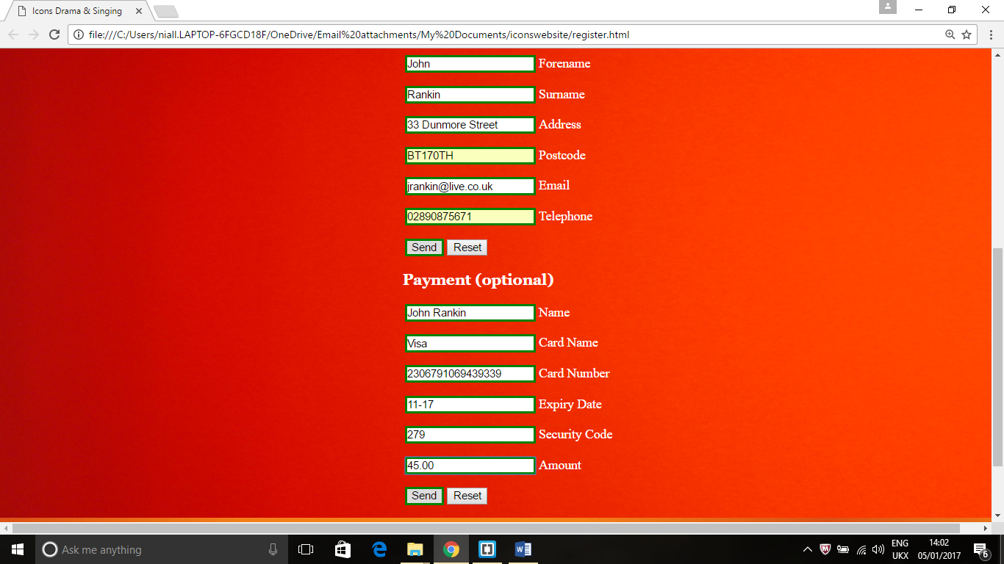

# **Screen Shot of Form (Empty input)**

Empty input brings up message ‘Please fill in this field’.

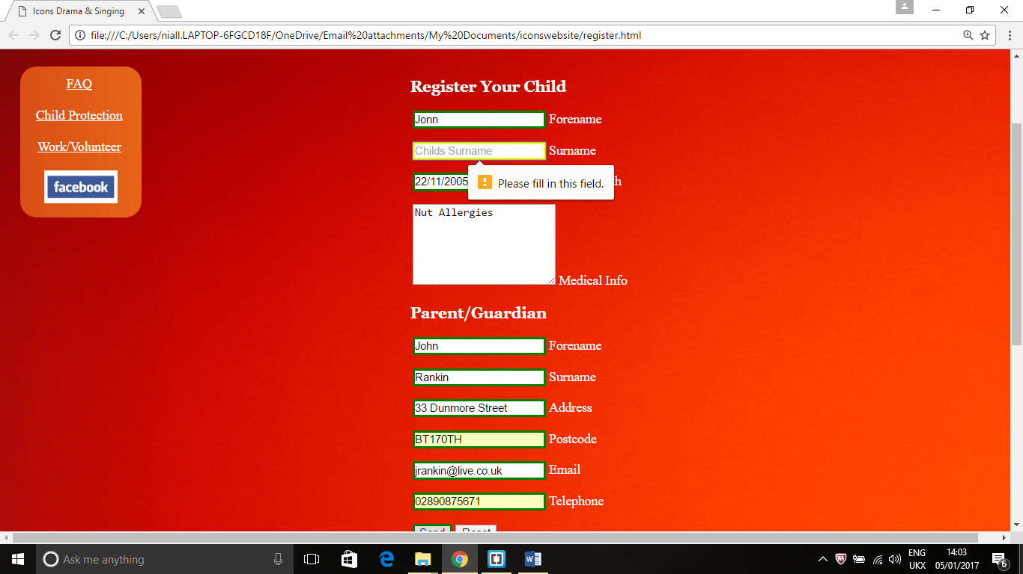

# **Screen Shot of Form (Invalid & Extreme inputs) - Email field**

When invalid data is entered the field box is yellow. When extreme data is entered the message appears, ‘Please match the format requested’.

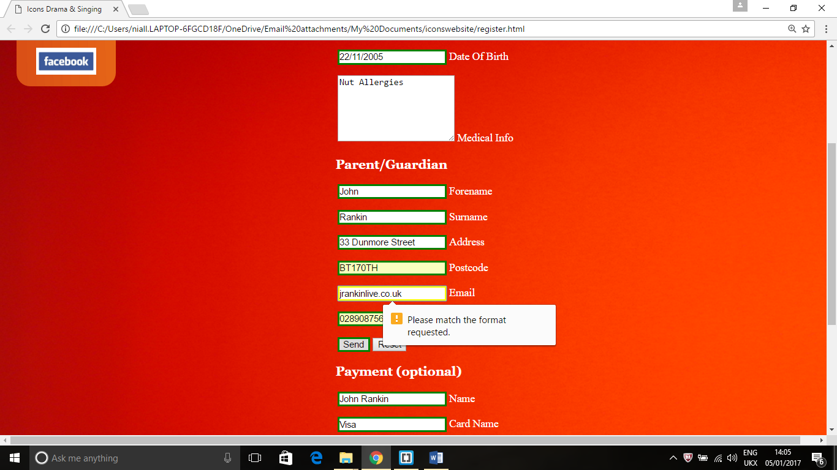

# **Screen Shot of Form (Invalid & Extreme inputs) - Post Code field**

When invalid data is entered the field box is yellow. When extreme data is entered the message appear, ‘Please match the format requested’.

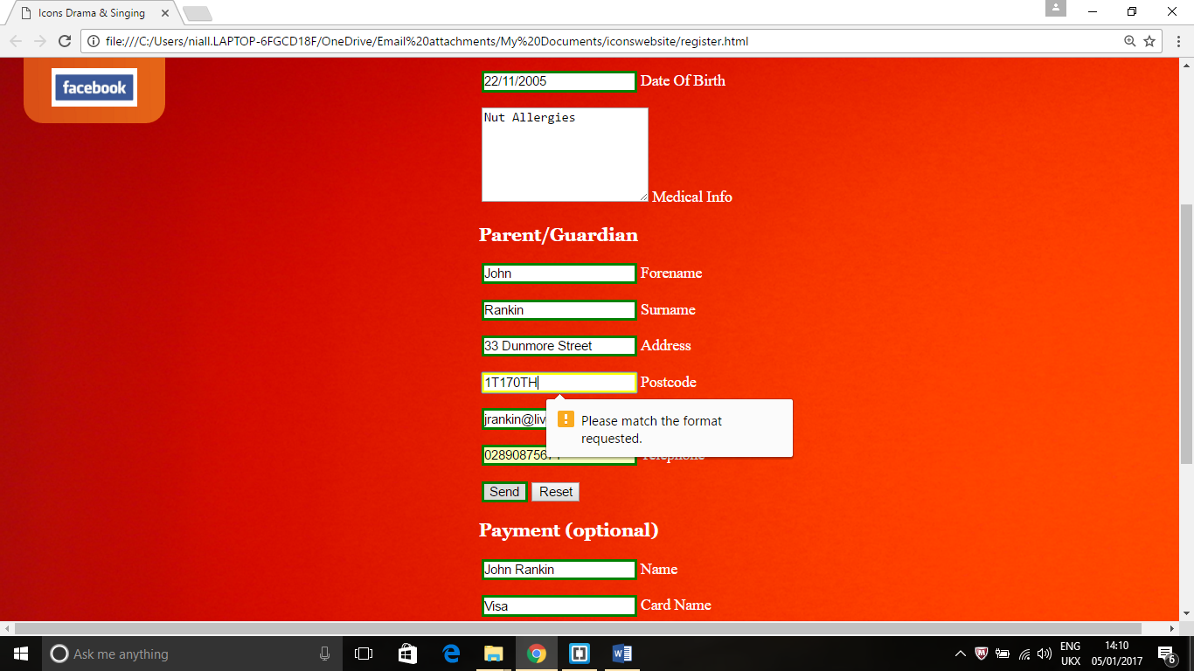

# **Screen Shot of Form (Invalid & Extreme Input) input into Phone Number field**

When invalid data is entered the field box is yellow. When extreme data is entered, the message appear, ‘Please match the format requested’.

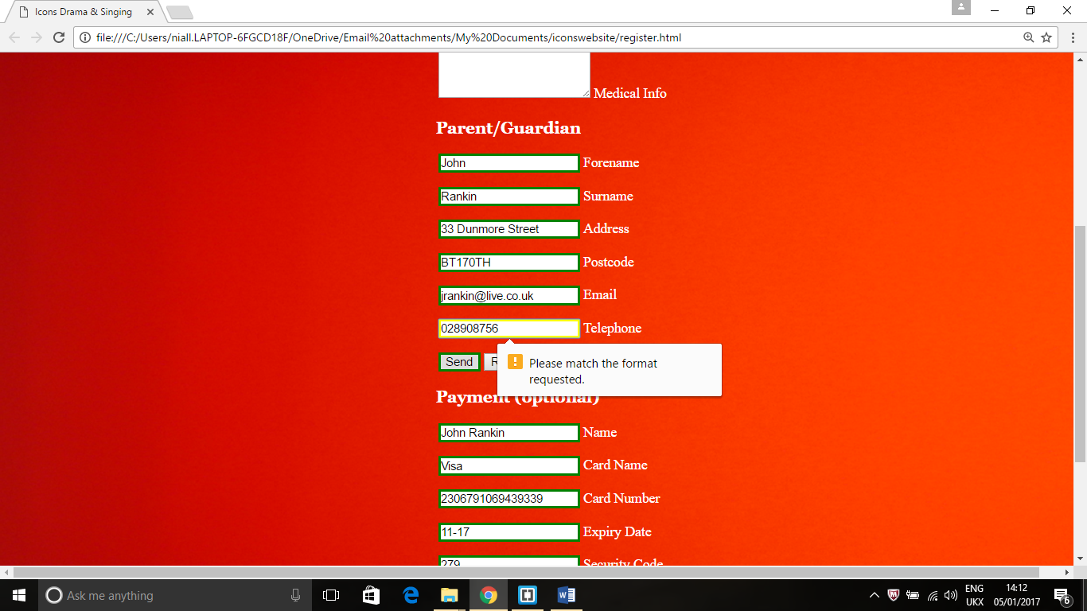

# **Screen Shot of changes made to Links in Main Navigation (disability.html)**

This is what happens when disability link was clicked in main navigation, this was also repeated in all other pages

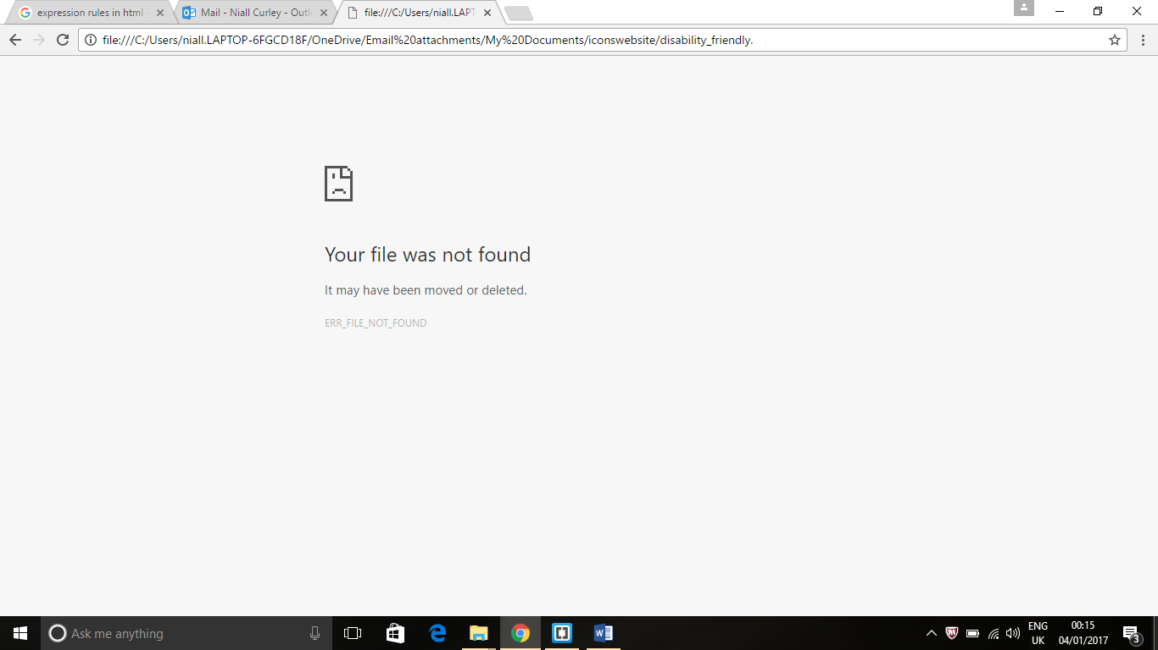

When the html code was checked it only had ‘disability_friendly’, rather than ‘disability_friendly.html’. Therefore it didn’t open correctly. This was copied unto all pages, so the main menu had to be updated in all pages.

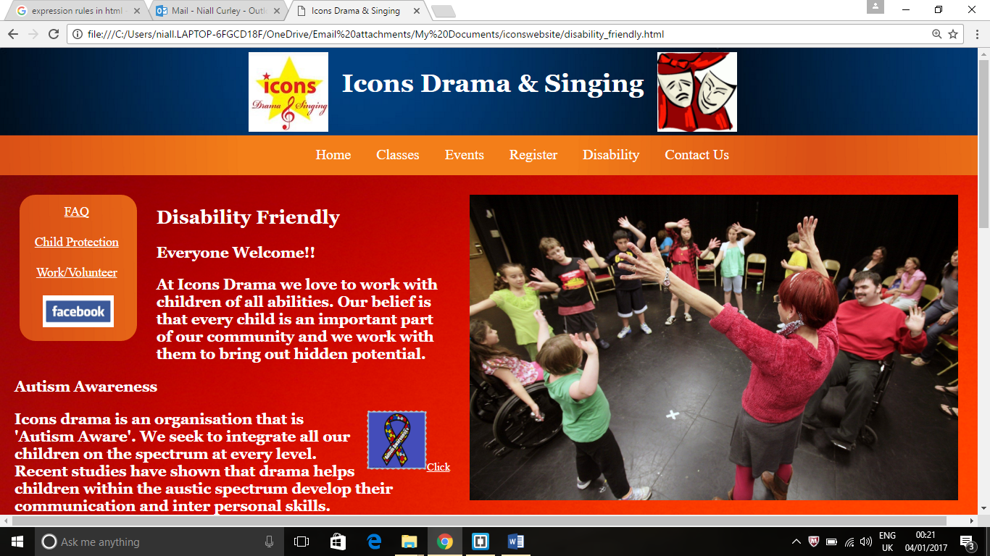

# **Screen Shot of Changes Made to Footer (all pages)**

In the footer navigation links, the link for the disability page was worded wrongly, it said ‘Disability Friendly’, instead of Disability.

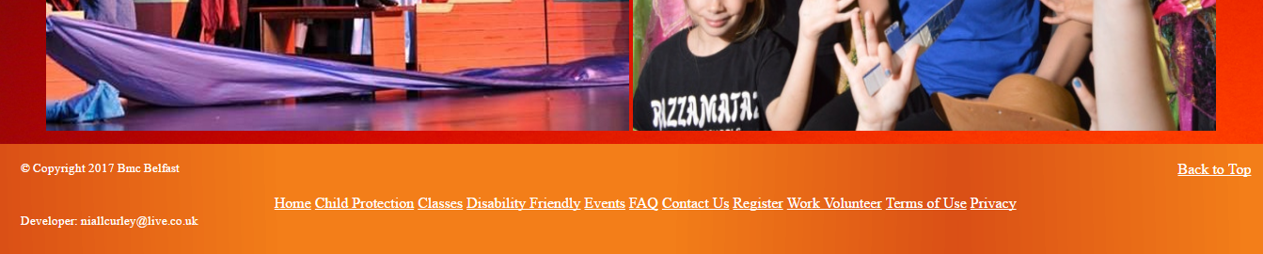

This was changed to ‘Disability’.

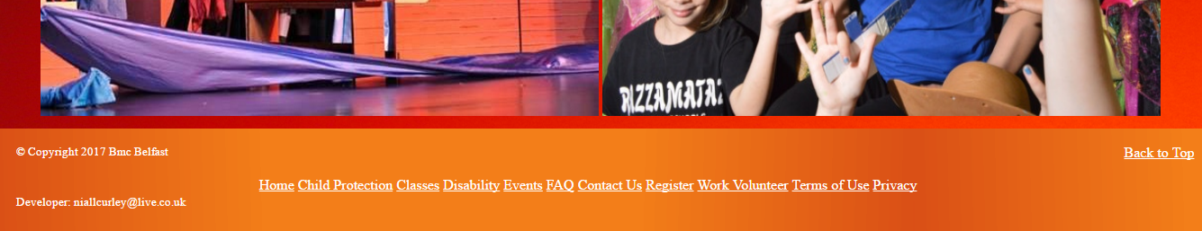

# **Screen Shot of Changes made to Home (index.html) Alternative Text**

As the alt feature was not included in the html code, the alternative text did not appear for this image ("images/index_youngkids3.jpg")

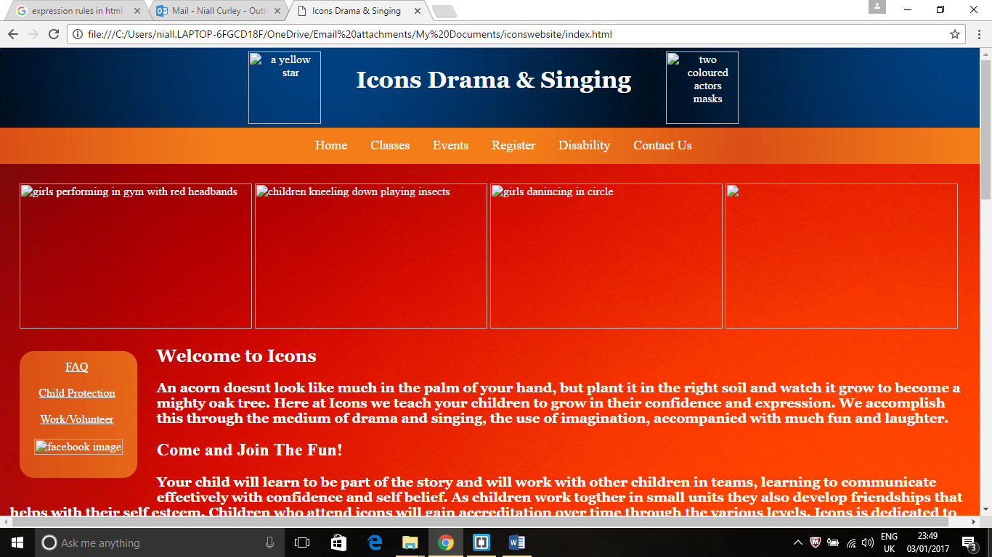

When alt feature is included the empty space is replaced by text (one child jumping with other kids clapping)

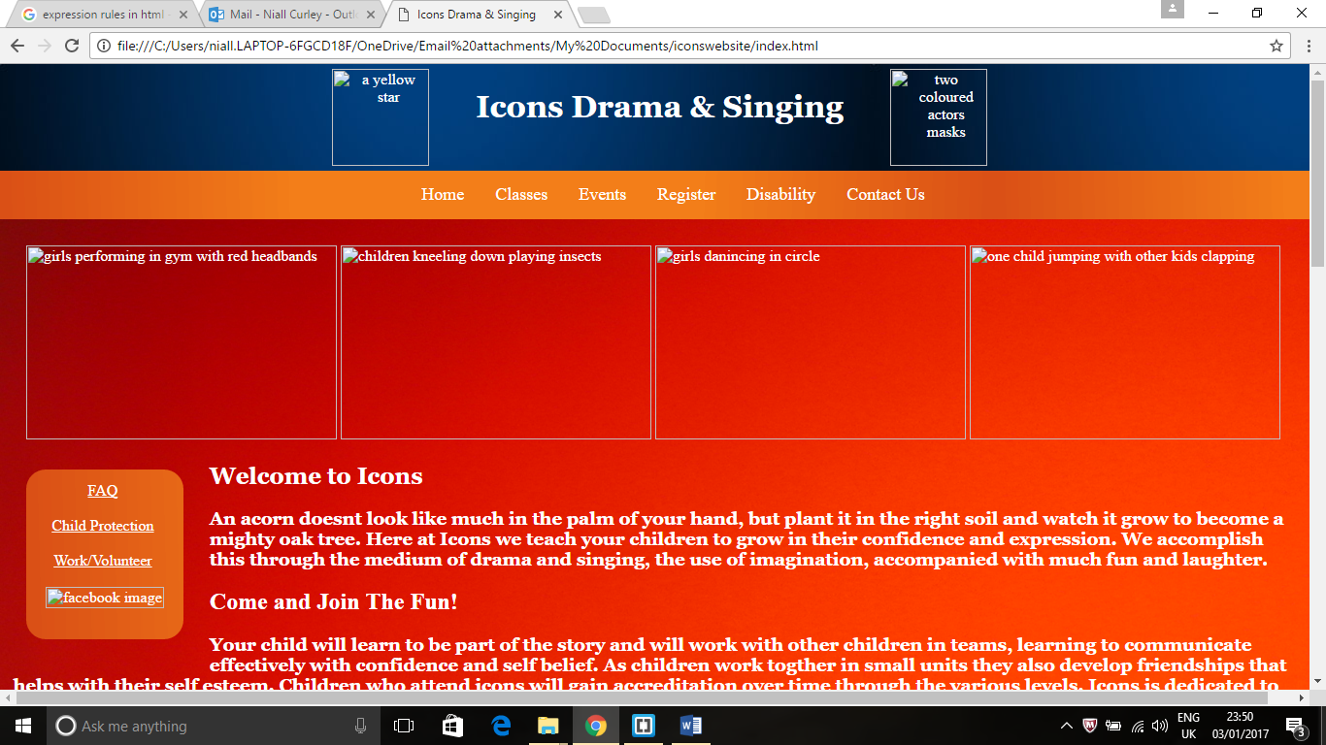

# **Changes made to Register (register.html)**

First name label was not the same as placeholder (forename).

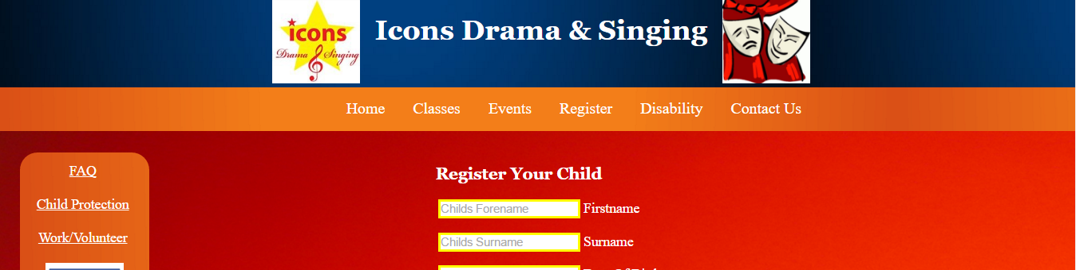

This was then changed in the register.html (below).



# **Screen Shot of Changes to Disability (Alternative Text)**

As the alt feature was not included in the html code, the alternative text did not appear for this image ("images/autism-awareness-ribbon-icon.png")

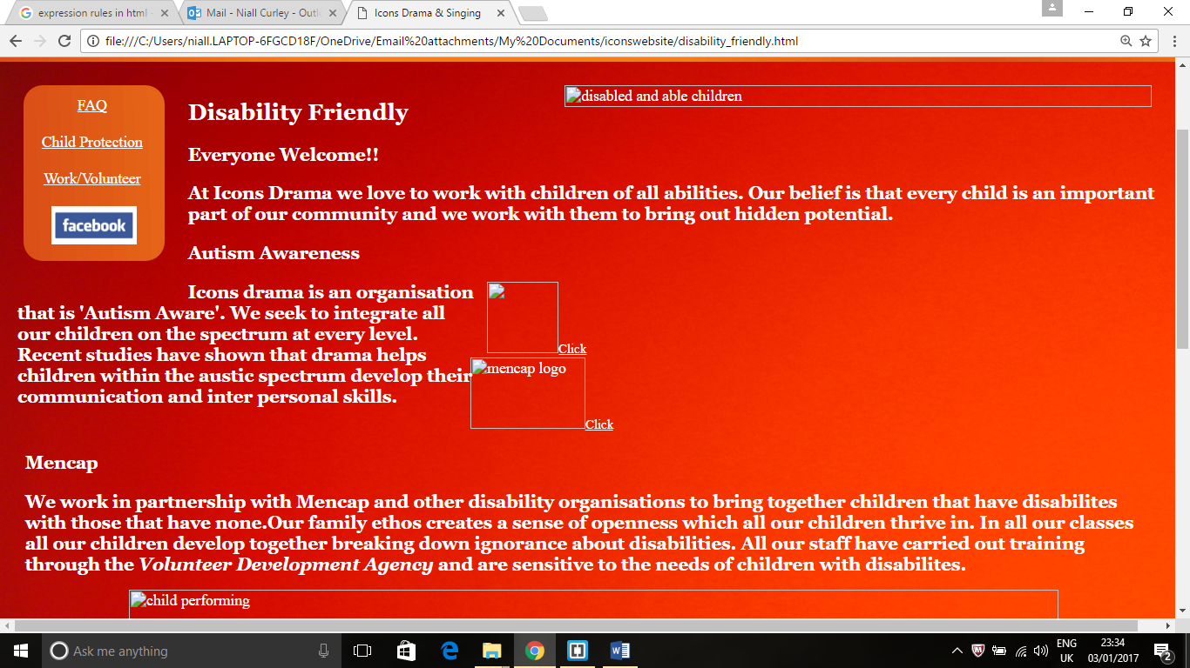

When alt feature is included the empty space is replaced by text (ribbon with autism logo)

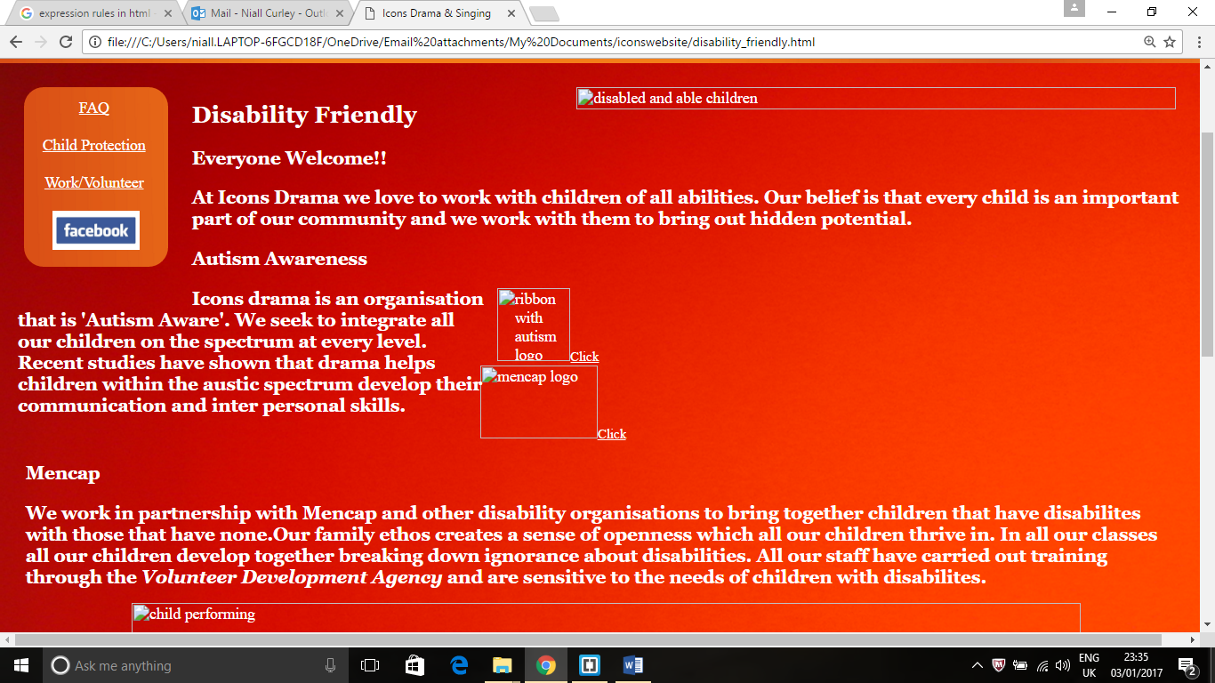

# **Screen Shot of Changes made to Contact Us (contact_us)**

Wrong text had been written into placeholder, ‘Child’s forename, Child’s surname’ instead of ‘Forename and Surname’.

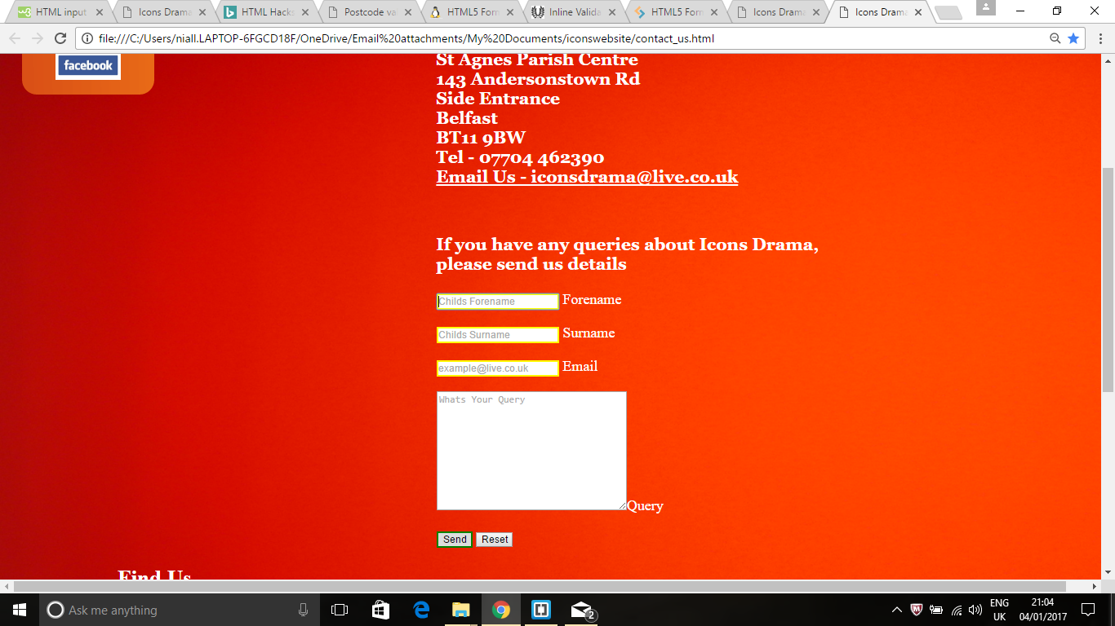

Changes made.



# **Report on Website**

Having reviewed this website from the functional & design specifications, the black box testing and a final questionnaire with the client, it is now necessary to look at the strengths, weaknesses and any suggested changes.

**Strengths** - The client wanted a website that would reach a certain audience, so several features were to be included in the design, male & female children, children of different ages, multicultural images of children, a disability friendly organization, safe child protection, ability to register & pay.

There is an abundant use of images of male and females on stage and in class. There are similarly plenty of images of children of different ages working *together. The use multicultural images work well to project the ethos of Icons* Drama.

Dedicating a separate page to *child protection*, highlights its importance. The use of large vibrant images of the Icons staff showing their focus on child protection organizations, displaying the *logos* of these organizations with addresses and *email links* is important.

A *disability page* shows how important it is to Icons that disabled children are welcome. Therefore, I used large images showing all the children expressing themselves together, both the junior and the seniors. This is encouraging for parents who may find this a sensitive issue. The extra *image links* to Autism Awareness and Mencap, help to create a sense of community working together.

The use of a *side bar* was necessary as the client wanted to have all the necessary links in clear view, like Child Protection, Work/Volunteer and Facebook link to Icons Facebook. Keeping the side bar the *same colour* as the main navigation draws your eye to it. As too many links in the main navigation would have been too much.

*Background colours* that are *gradient* from red to orange in the main body and blue to black in the header sets off these areas making them attractive and vibrant. *White coloured text* that is large, makes it easier to read and as there is not too much text, it gives the pages a sense that it is simple to understand.

*The forms* on the register, contact us and work/volunteer page were detailed and comprehensive, they highlight when input is *empty, valid, invalid and extreme*, this helps to deal with any problems with wrongly submitted information from the user’s side.

*The FAQ page* answers generally all the questions a user might have about the functions of the Icons Drama. There are *not* too many questions, the questions are to the point, and the answers are easily found.

The *footer section* has all the relevant links that are in the main navigation and the side bar, it also has additional links to Terms of Use and Privacy pages which detail any legal obligations of the Website and Users. The back to top feature is also useful for moving up the page more quickly.

**Weakness** – The *questionnaire* brought out several weakness’s that have become apparent. Firstly, was *the use of images* in the bottom of the home page which were too large, they are too overpowering and too close together. Looking at the other pages like events and the work/volunteer pages, a large image looks better on its own rather than beside others.

Toni mentioned the fact that there were too many forms, there are forms on three pages, register, contact us and work/volunteer. I thought this was necessary at the time to differentiate these forms. But I can see Toni’s point, it would be better if they could be amalgamated into one form, for both user enquires, volunteer enquiries and registration.

**Changes** – *I will change* the layout of the *images* in the Home page and move larger images at the bottom in a *staggered fashion* to the left and right side. I will add more text for each of the images. These will be spaced out better to make it easier to view each image without being overpowered by the others.

The forms on the registration, contact us and the work/volunteer pages will be amalgamated into one form to make it more user friendly. This will mean putting this one form into the registration page, it will contain a drop down choice menu for, register, work/volunteer and enquiry. There will be an option part for paying for registration fees at the bottom as there currently is in the child registration. I will put a link in the work/volunteer page and contact us page that links to the register page.

Toni mentioned the use of videos in the *homepage* and in the *events page*. This will be a new feature as it was not mentioned up to this point. I will add two videos in both these pages using the ‘controls attribute’.

# **Review of FAQ**

There are currently eight questions and answers on the Frequently Asked Questions page.

Top

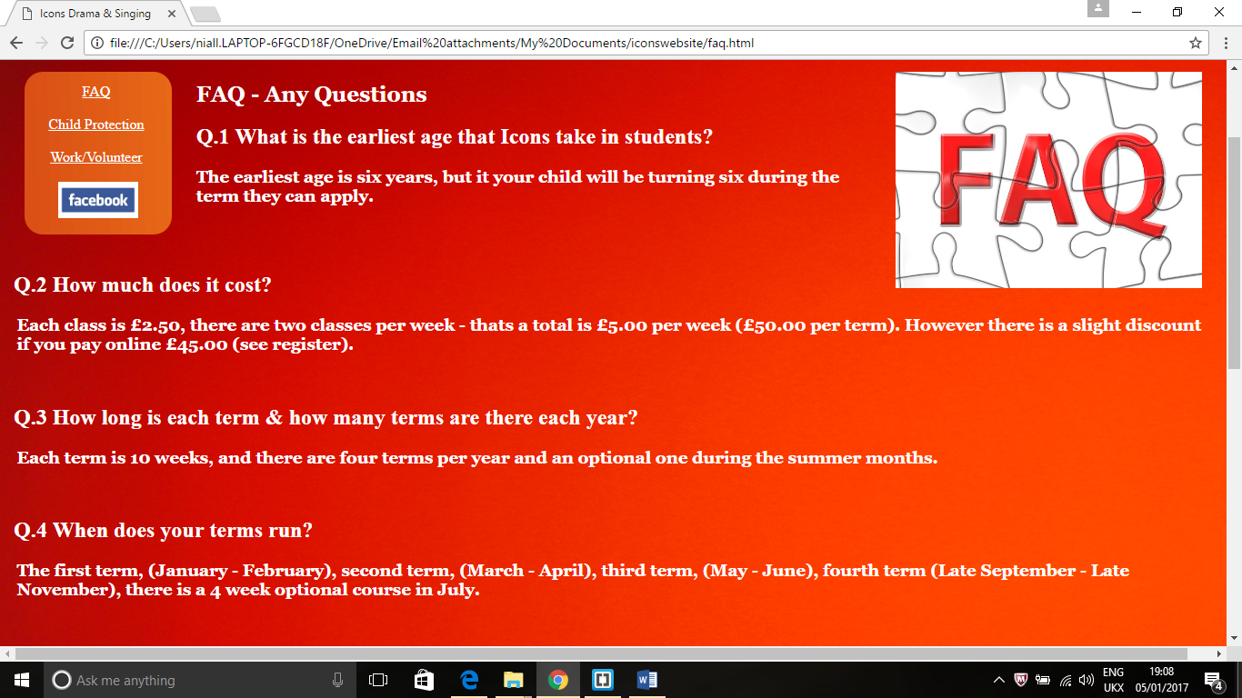

Bottom

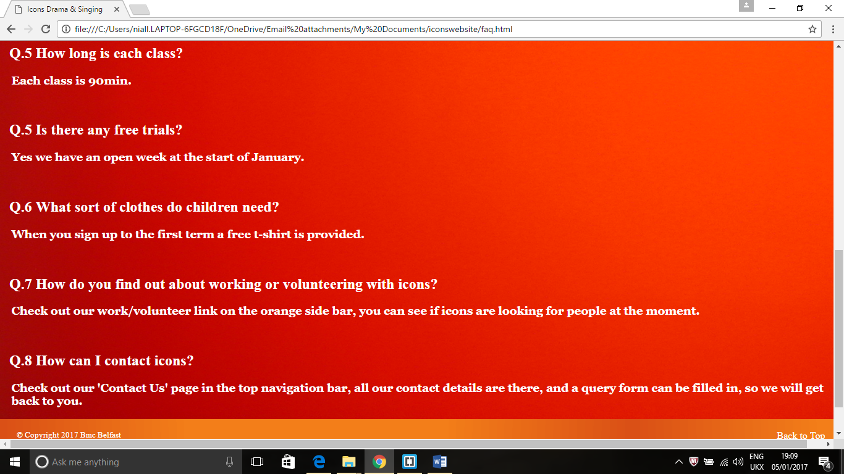

## **Actual Questions**

Q.1 What is the earliest age that Icons take in students? - The earliest age is six years, but it your child will be turning six during the term they can apply.

Q.2 How much does it cost? - Each class is £2.50, there are two classes per week - that’s a total is £5.00 per week (£50.00 per term). However, there is a slight discount if you pay online £45.00 (see register).

Q.3 How long is each term & how many terms are there each year? - Each term is 10 weeks, and there are four terms per year and an optional one during the summer months.

Q.4 When does your terms run? - The first term, (January - February), second term, (March - April), third term, (May - June), fourth term (Late September - Late November), there is a 4-week optional course in July.

Q.5 How long is each class? - Each class is 90min.

Q.5 Is there any free trials? - Yes, we have an open week at the start of January.

Q.6 What sort of clothes do children need? - When you sign up to the first term a free t-shirt is provided.

Q.7 How do you find out about working or volunteering with icons? - Check out our work/volunteer link on the orange side bar, you can see if icons are looking for people now.

Q.8 How can I contact icons? - Check out our 'Contact Us' page in the top navigation bar, all our contact details are there, and a query form can be filled in, so we will get back to you.

This list of questions is quite basic and answer only the simplest user queries. I would need to include several other questions that would tie in better with the rest of the site (see below).

## **Improvements – FAQs**

These improvements should make this page more comprehensive.

Q.9 Does Icon Drama take children who have disabilities? - ‘Yes, Icons Drama takes children from all disabilities, we work closely with various disability organizations, see our ‘Disability’ section.

Q.10 Are your staff and volunteers covered under all relevant child protection vetting and training? - ‘Yes, all our employees and volunteers checked by Access N.I and are trained with Keeping Safe’, see Child Protection section.

Q.11 What events and shows do you have up and coming? - ‘There are several shows in production every year, see our ‘Events page’.

Q.12 Can you Register your child without going to the address? -‘Yes, you can register your child, see the Register page, you can also pay term fees at a reduced rate’.

Q.12 What if forms do not submit on the Register page? - ‘Send us a message using the form in the Contact Us or by the Email link on the same page, failing that then ring our organization – 07704462390.

Q.13 What if images or important text is not appearing on this website? - ‘Sometimes different browsers can affect the visual images that a website normally displays, try a different browser like Google Chrome or Internet Explorer’.

Q.14 Who should I contact if there is a problem with Icons website? - ‘Please contact us by Contact Us page or the email link [iconsdrama@live.co.uk](mailto:iconsdrama@live.co.uk) on the same page or contact our Developer – [niallcurley@live.co.uk](mailto:niallcurley@live.co.uk) .

These changes will be implemented before the site goes online.

# **Maintenance of the Icons Website**

We now need to look at the maintenance of the website and set in place a plan for this, as all websites require this. Mostly this is down to the web developer (Niall Curley), but it also involves the client and in fact both work together to produce a top-quality product.

**Risks** – a website that doesn’t get continual maintenance can become irrelevant and outdated. This can lead to problems with your customers not being able to access your product and with a loss of revenue for your business. It can also lead to increased costs in repairing any problems. Weekly and monthly updating and keeping on top of any problems is the way to maintain a healthy attractive website.

**Main problems areas** – Out of date images, out of date information, forms for payment not working, forms for information not working, links and images not working.

# **Support & Maintenance**

**Developer – Niall Curley**

**Client – Toni McCann (icons drama)**

**Dated – 5.1.2017**

# **Daily Maintenance**

|  |  |  |
| --- | --- | --- |
| **Research** | **Responsible** | **Description** |
| New Information | Client | Client needs to keep note of any changes to their organization like dates for shows, classes being cancelled. New rates being charged for your services. These will be updated directly by the client who will be trained for this task. |
| Email & Forms | Client - Developer | The client needs to keep a note of any emails and queries. Both in relations to their own business and to the Website functioning. Any problems with the website should be given to the developer. |
| Software Intrusion | Developer | The developer needs to have their software protected with anti-virus software and have this subscription paid and software up to date. |
| Editor Tools Software | Client | Checks can be made with editor spell checker, links and images - positioned correctly (Dreamweaver) |
| Copying | Developer | Copies of the website will be made and stored on a separate storage for any serious problems developing. |

# **Weekly Maintenance**

|  |  |  |
| --- | --- | --- |
| **Research** | **Responsible** | **Description** |
| New Information (Content) | Developer/Client | Content and information relating to classes or shows, classes cancelled or holidays will need to be weekly updated. |
| Links (all) | Developer | The developer will check that all the links are working correctly both internal and external. All forms will be checked and email links with attention to payment forms. |
| Images | Developer | Images will be tested for quality and alternative text has been added for accessibility reasons. |
| Terms of Use/Privacy | Developer | These legal documents will be checked and changes updated by the developer. The client will be made aware of these changes by the developer. |
| Copyright | Developer | This will be checked for display at all times (footer). |
| Meta Data | Developer | This will be reviewed to make sure the website is getting traffic. |
| Date of Modifications | Developer | The developer will make sure that modifications are stored and displayed. |

# **Monthly Maintenance**

|  |  |  |
| --- | --- | --- |
| **Research** | **Responsible** | **Description** |
| Content (Events page & Events page) | Client/Developer | The client will inform the developer if there is to be any changes text or images. |
| Reports will be run on Dreamweaver or another checker | Developer | This will check the coding for and changes that have been made, in texts, or any information missing. |
| Performance of Browser | Developer | Free tools can be used to test performance of website. |
| FAQs | Developer/Client | This page will be updated if any information has become irrelevant. |
| Updates | Developer | Any updates or improvements known to the developer who has expert knowledge of the industry will be logged and considered with client’s approval. |

# **Yearly Maintenance**

|  |  |  |
| --- | --- | --- |
| **Research** | **Responsible** | **Description** |
| Website Review | Developer/Client | A review of the whole website and its relevancy to the said industry will be checked. If there are any modification necessary. All the images, colours, text, videos, general arrangement will be up for discussion. |
| Review license | Developer/ Client | Check with web host provider for any new fees or costs. |
| Review Website Stats | Developer | This can be done by checking analytics of the major web browser such as google. |

# **Appendix**

# **Questionnaire**

Having completed the icons website and having tested and fixed and errors, I then contact my client Toni McCann to get feedback. I used a questionnaire as part of this interview.

**Time/Date of Interview** – 4pm, 41.2017.

**Address** – St Agnes Parish Centre, Belfast.

**Person Interviewed** – Toni McCann

**Q.1 Does the website meet your expectations visually?**

‘Yes it looks well, it really stands out, im impressed’.

**Q.2 Are the colours and background colours right?**

‘Yes they are what I wanted, very vibrant. Its good the way you have two different colours in the background integrating like that’.

**Q.3 Does the site meet your needs?**

‘Since we only advertise on Facebook, I always wanted website like this with different page to show off what we do here. It seems to have most of the things that I wanted’.

**Q.4 Do you think it will appeal to your audience?**

‘I think it will appeal to them, building confident children is very important to parents these days. Child protection is a big thing these days and having a multi-cultural image is important’.

**Q.5 Are there the right number of links to social media and other organizations?**

‘Yeah im happy enough with the links, we are only advertised locally and on Facebook. We advertise at St. Marys Teacher training for volunteers, and with Autism Awareness and Mencap’.

**Q.6 Are the links easy to see?**

‘Yes the colours change as you hover over the links so it are easy to see’.

**Q.7 Is the text and script the right type?**

‘Yes the writing seems large enough to see and is the right style’.

**Q.8 Do the forms meet your requirements?**

‘The forms are okay, I think they could be improved, and possibly integrated to make it easier for anyone making enquiries about volunteering or registering their child. Maybe you could combine register page and the work/volunteer page’.

**Q.9 Are there enough images on the site?**

‘I gave you all these images and I think there is enough, but now I think that on the home page for instance, you have too many images together, particularly at the bottom, they are too large. And at the top there are too many together. I would like them to be more like the events page which is more spaced out’.

**Q.10 Are there any other improvements?**

‘I think I would like some videos in the home page and on the events page’.

**Q.11 Overall what’s your view on the website?**

‘I like it, with a few more changes it should be right, and can’t wait to get it up and running for advertising’.